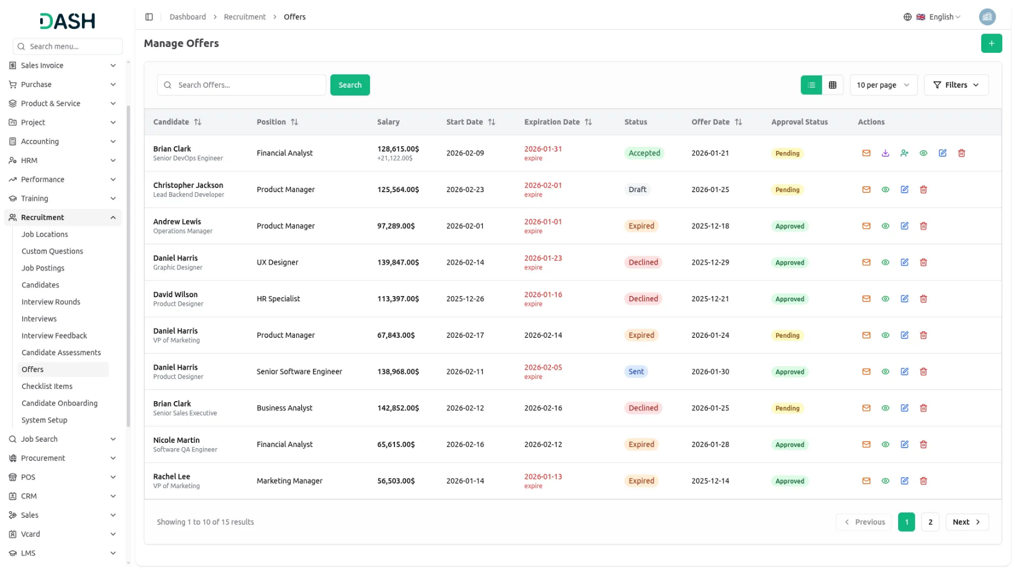
Our Recruitment Management solution offers a streamlined, end-to-end platform for managing the entire hiring process. From creating job postings and tracking candidates to scheduling interviews and generating offers, it simplifies recruitment workflows. With features like real-time dashboards, automated onboarding, and customizable configurations, this solution ensures efficiency and a seamless experience for both recruiters and candidates.

Recruitment Dashboard Insights
Transform your hiring process with a dashboard that offers real-time insights into your recruitment pipeline. Track key metrics like total candidates, active job openings, scheduled interviews, and successful onboardings. The integrated calendar ensures no interview is missed, while interactive charts display candidate progression and hiring funnel conversion rates. The attention-required section highlights pending onboarding tasks, and the career page link copy feature makes sharing job opportunities easy.
- Real-time recruitment metrics tracking across all stages.
- An interactive calendar for efficient interview scheduling management.
- Visual analytics with donut charts and hiring funnels.
- Onboarding task monitoring with alerts for pending actions.
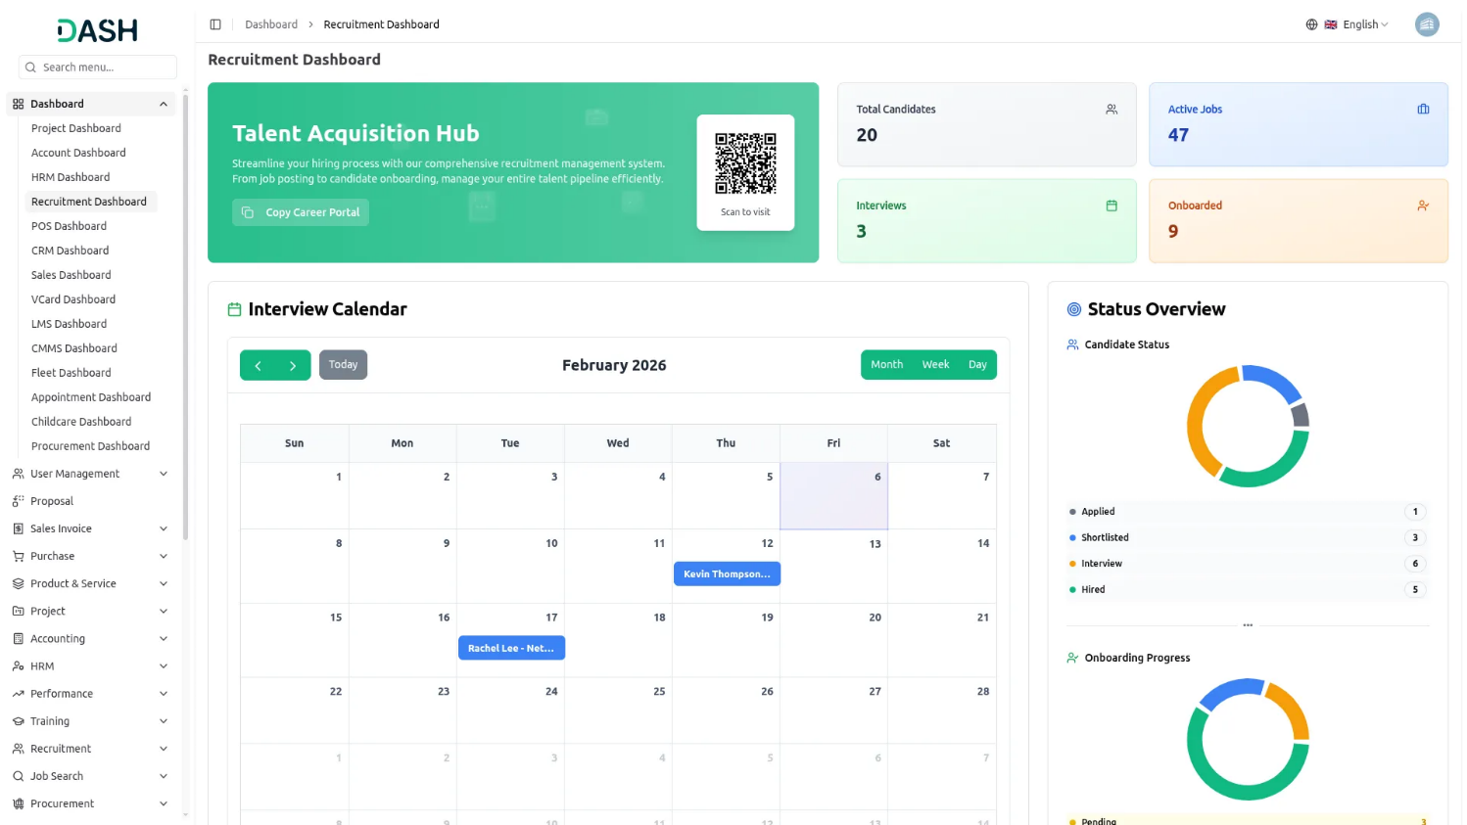

Comprehensive Job Posting
Create and publish job openings on your career portal with ease. Set up complete job details, including title, location, salary range, required skills, and application deadline. Customize your application form by adding custom questions and terms & conditions that candidates must accept. All applications submitted through your career portal are automatically saved in your system, making it simple to review and manage candidates throughout your hiring process.
- Create detailed job postings with requirements and benefits
- Customize application forms with questions and terms and conditions
- Publish or unpublish jobs directly on the career portal
- Automatically collect and manage all submitted candidate applications

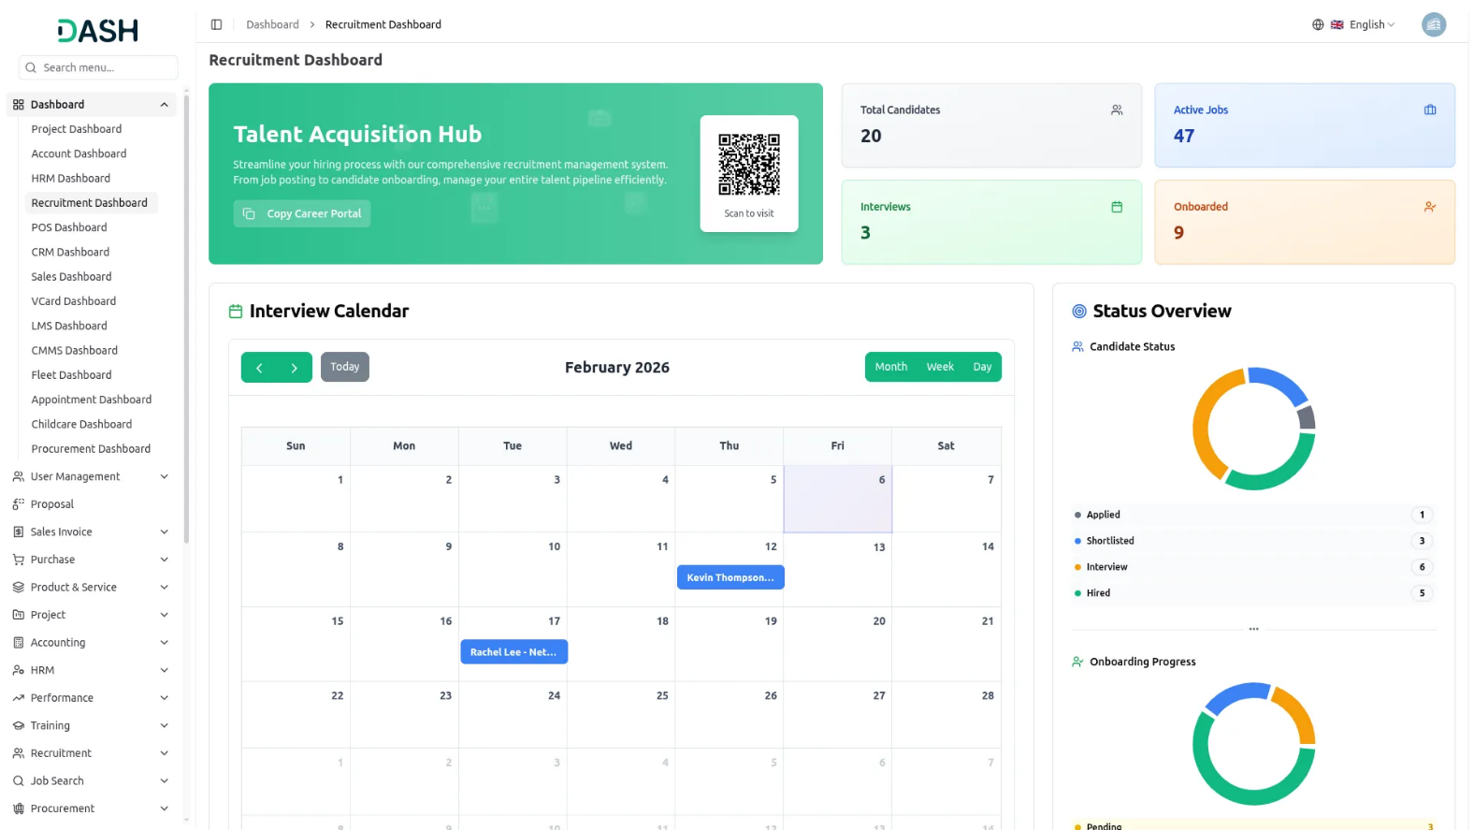

Employment Offer Generator
Create professional, consistent employment offers with template-based generation tools. Use dynamic placeholders to automatically fill in candidate details, position info, salary, benefits, and start dates. Track the entire offer lifecycle, from creation to acceptance, including offer status, expiration dates, and approval workflows. Generate PDF offers, send them directly to candidates, and convert accepted offers into employee records. Monitor salary negotiations, bonuses, and equity allocations while ensuring compliance with compensation policies.
- Template-based offer generation with dynamic placeholders.
- Track a complete offer lifecycle from creation to acceptance.
- Integrated approval workflows for streamlined offer authorization.
- One-click conversion of accepted offers to employee records.

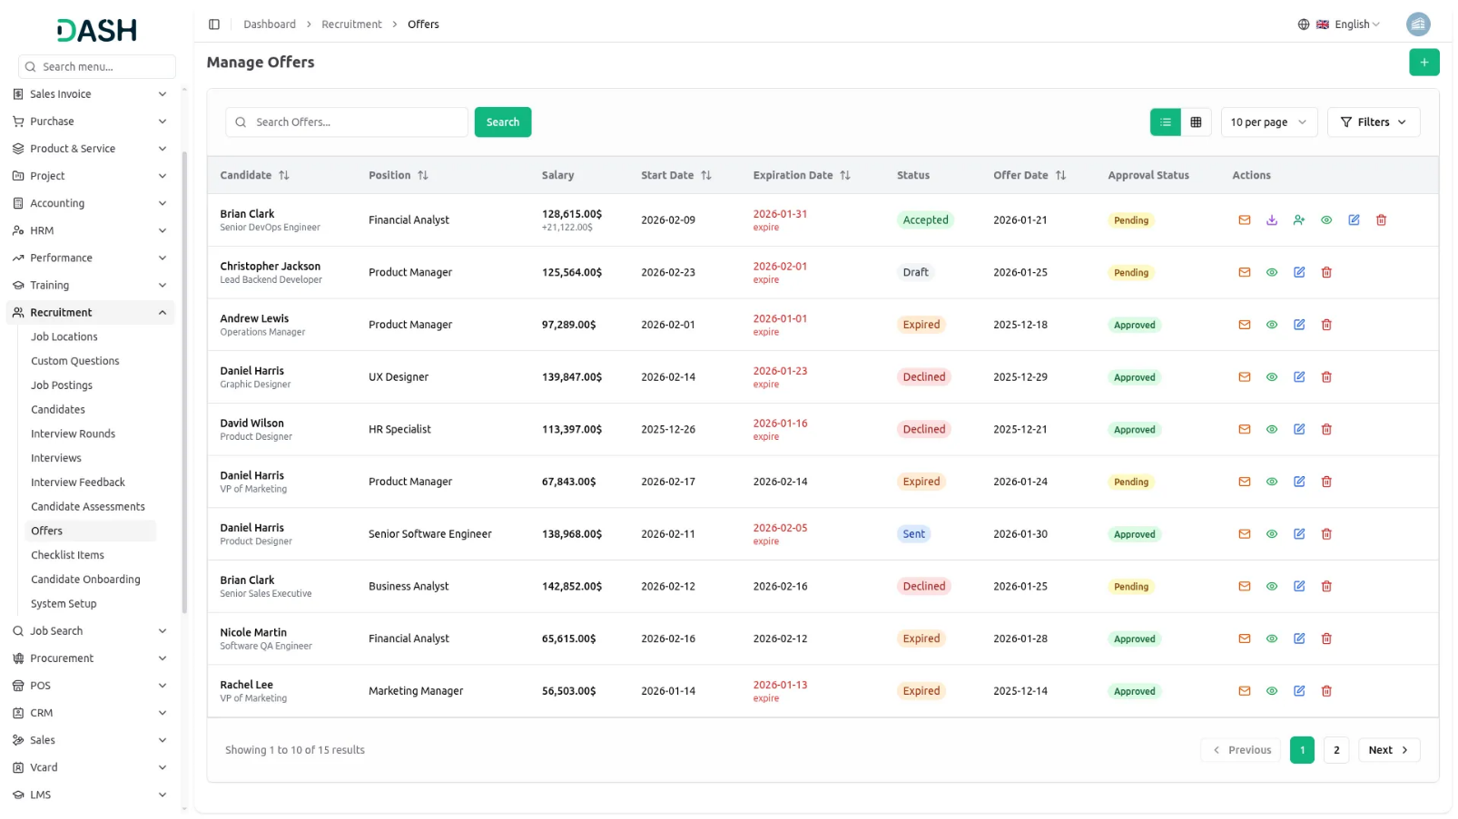

Complete Candidate Management
Streamline the application process with an intuitive system that captures essential candidate details while respecting their time. Collect personal information, professional background, and allow profile photo, resume and cover letter uploads. Integrate role-specific questions and display transparent timelines with tracking identifiers to keep candidates informed. Offer accessible support channels with contact information for application assistance.
- Structured application forms for personal and professional data.
- Document upload for profile photo, resumes and cover letters.
- Dynamic custom questions tailored to specific positions.
- Transparent application status tracking with unique identifiers.
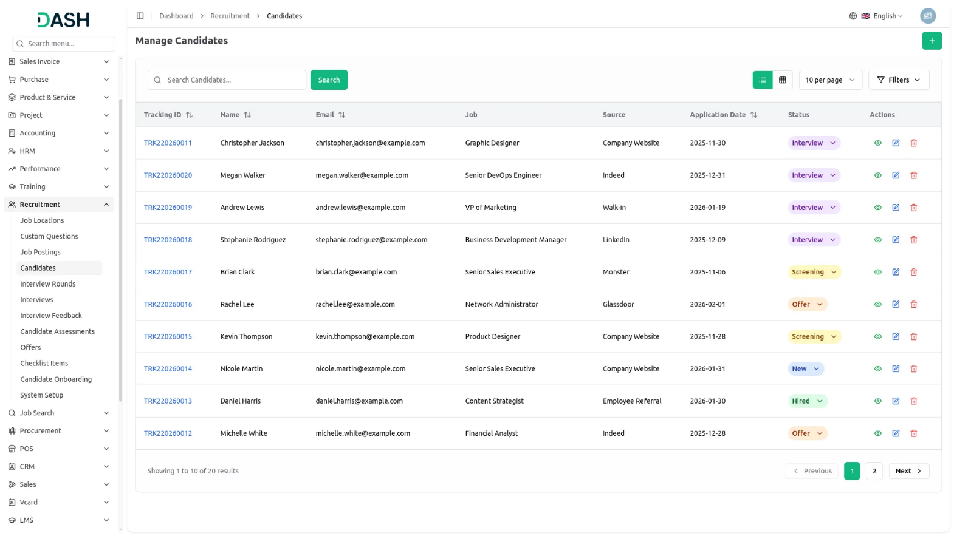

Recruitment Configuration Hub
Establish a robust recruitment foundation through comprehensive configuration modules that define job categories, employment types, candidate sources, and reusable onboarding checklists with automated task assignments. Configure interview types, assessment criteria, and career portal branding with company logos and messaging that reflect your employer brand while maintaining evaluation consistency across your organization.
- Configurable job categories and employment type definitions.
- Customizable onboarding checklists with automated task management.
- Flexible candidate source and interview type configurations.
- Complete career portal branding with logos and messaging.
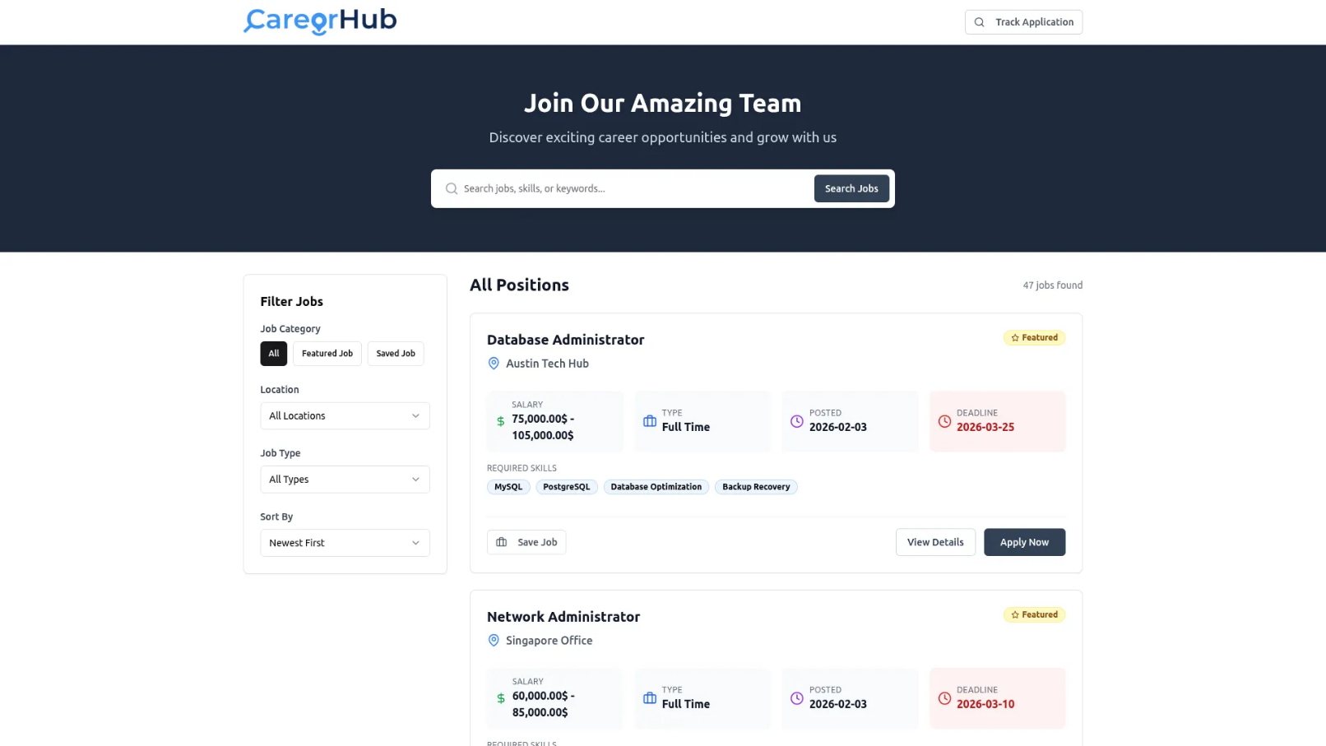

Advanced Interview Scheduling
Coordinate complex interviews with efficient scheduling and feedback management. Organize multi-round interview sequences with customizable stages, and schedule interviews with precise dates, times, and virtual or in-person links. Capture structured feedback on key competencies using standardized rating scales. Generate evaluation reports, track candidate assessments, and maintain a complete interview history for decision-making.
- Multi-round interview configuration with sequence management.
- Flexible scheduling for physical and virtual interviews.
- Multi-interviewer assignment with coordination tools.
- Structured feedback collection with standardized competencies.
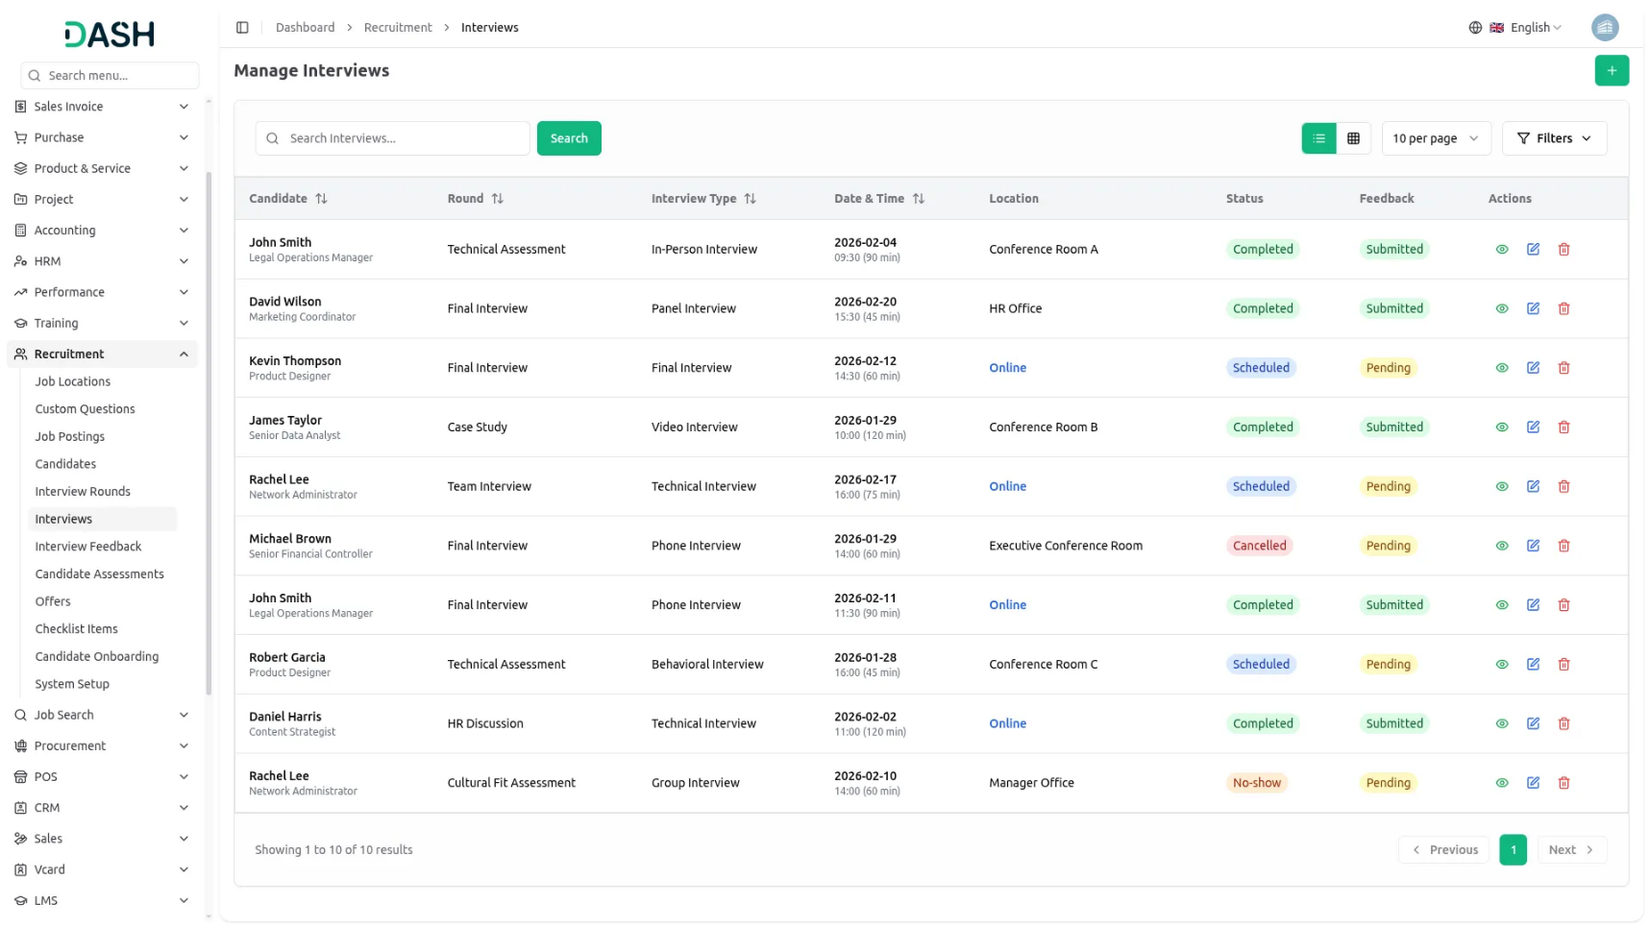
Introduction
The Recruitment Management Add-On is a comprehensive software solution designed to streamline your entire hiring process from job posting to employee onboarding. This system helps you manage, publish openings on your career portal, track candidates through the interview process, collect feedback, send offers, and onboard new hires, all in one platform. The Add-On includes a powerful dashboard for monitoring recruitment metrics, a customizable career website for candidates, and backend tools for HR teams to efficiently manage every stage of hiring.
How to use the Recruitment Add-On?
Company & HR Dashboard
- After purchasing and installing, navigate to the sidebar and search for the Recruitment Management Dashboard.
- The Recruitment Dashboard gives you a complete overview of your hiring activities at a glance. At the top, you will find a Career Page Link button that lets you copy the link to your public careers page and share it with potential candidates.
- The dashboard displays four important cards showing Total Candidates, Total Active Jobs, Total Interviews, and Total Onboarded employees. These cards help you quickly understand your recruitment volume and progress.
- Below the cards, an Interview Schedule calendar shows all upcoming interview appointments, making it easy to stay organised. A vertical Doughnut chart displays Candidate Status and Onboarding Progress data, giving you a visual breakdown of where candidates are in your hiring funnel.
- The Hiring Funnel section shows the number of candidates at each stage: Applications, Shortlisted, Interviewed, and Hired. This helps you identify bottlenecks in your process.
- Finally, the Attention Required section highlights any pending candidate onboarding tasks that need your immediate action, ensuring nothing falls through the cracks.

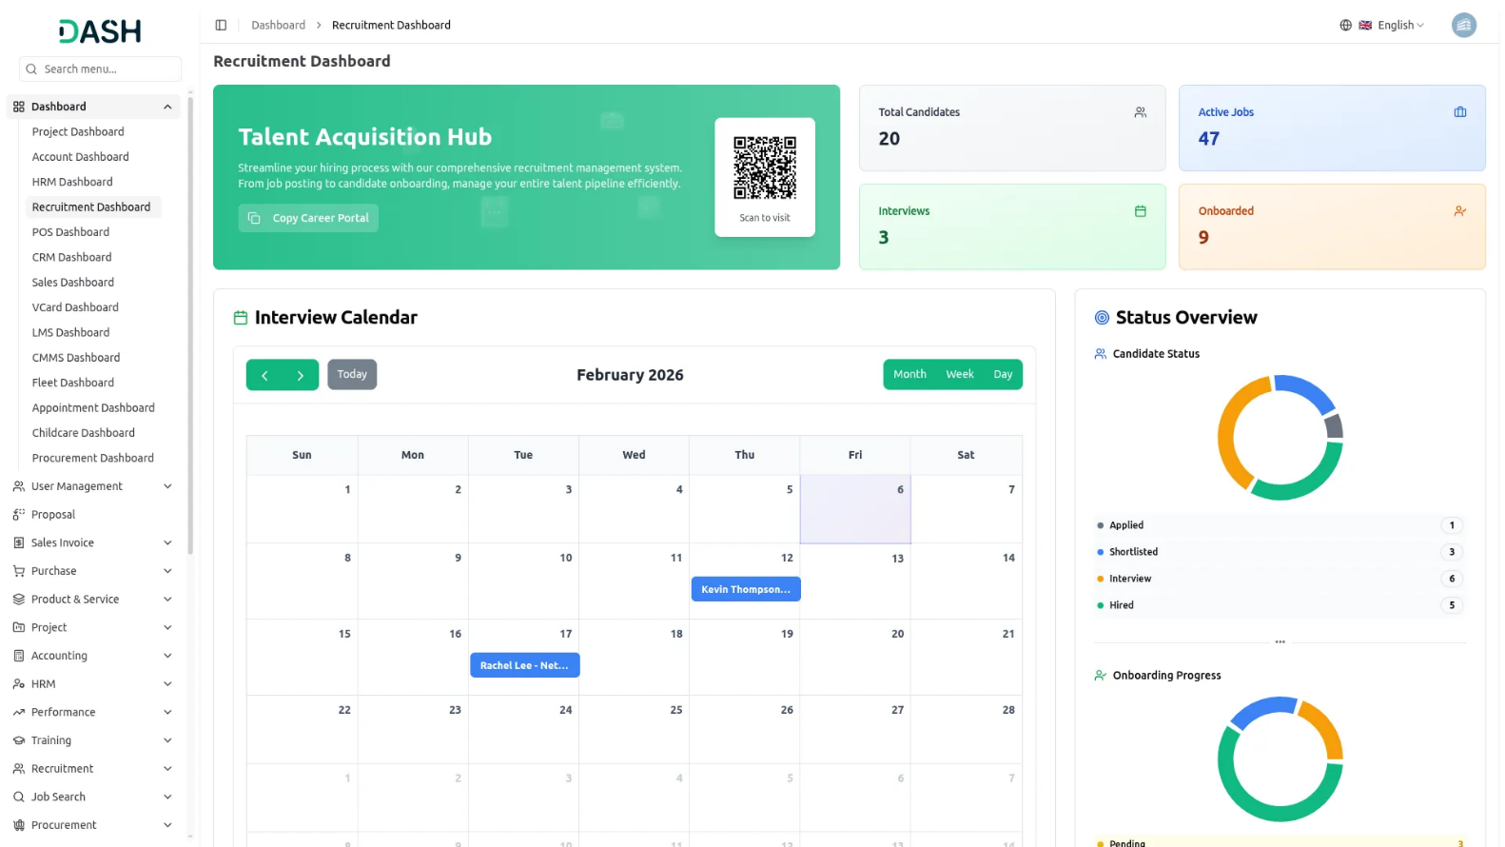

User dashboard
- The My Recruitment Dashboard gives you a complete overview of your personal recruitment activities at a glance. At the top, you will find four important cards showing My Interviews, My Onboardings, Assessments, and Feedback. Each card displays the total count along with status breakdowns (pending, completed, conducted, or submitted).
- The Attention Required section highlights any urgent tasks that need your immediate action, such as pending interview feedback awaiting submission. Click the “Review” button next to any alert to address these items promptly and keep your recruitment process moving smoothly.
- Below that, the Recent Interviews section displays your upcoming and scheduled interviews with candidate names, job positions, and interview dates, making it easy to stay organised.
- The Recent Onboardings section shows newly onboarded candidates or displays “No recent onboardings” when there are none to review.
- Finally, the My Task Progress section at the bottom tracks your assigned tasks across Interview Tasks and Onboarding Tasks. Each task category shows the number of pending and completed items along with the total count, giving you a visual breakdown of your daily recruitment responsibilities and helping you prioritise your activities effectively.
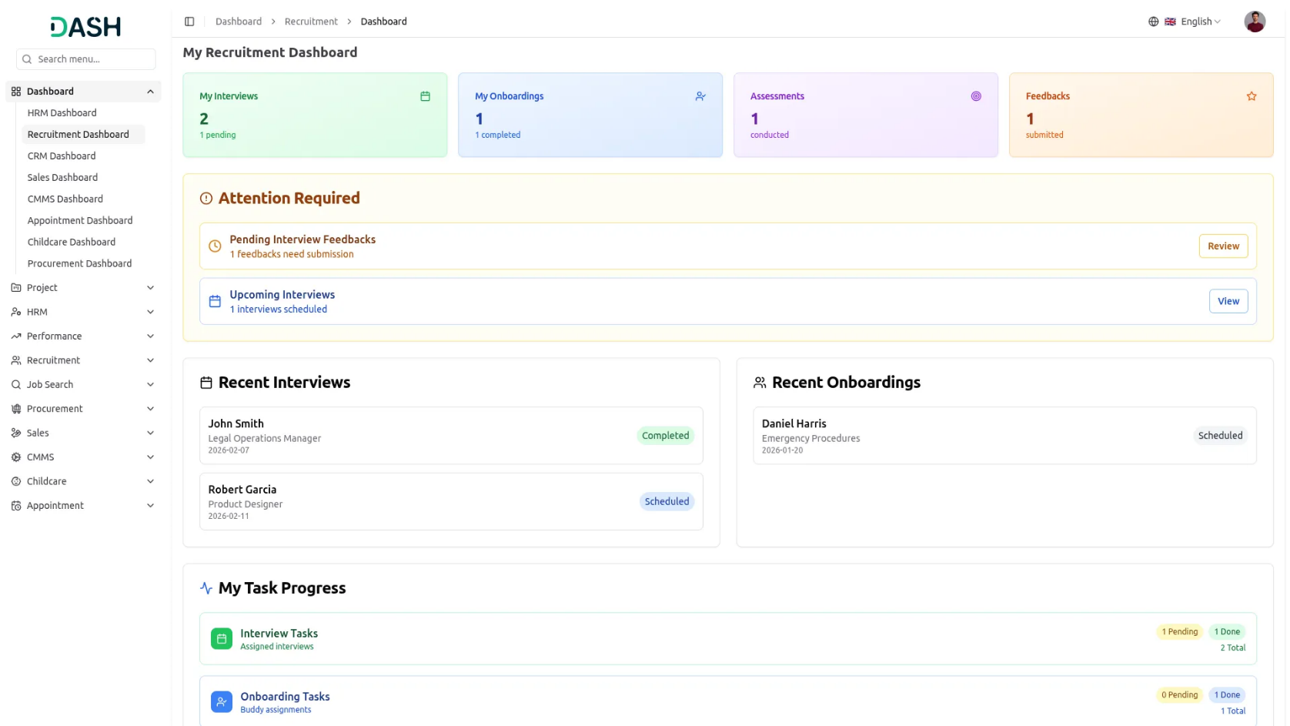
Manage Job Locations
- To add a new Job Location, click the “Create” button. Enter the Name of the location and check the Remote Work checkbox if this is a remote position. Fill in the Address, City, State, Country, and Postal Code fields. Select the Status as Active or Inactive and click “Submit”.
- The list page displays all locations with columns for Name, Address, Country, Type, and Status. Use the Search button to find specific locations or switch to Grid View for a different layout.
- Available Actions you can use: View to see complete Job Location Details, including all address information. Also, you can edit the location to update any details or delete it if no longer needed.
- On the website, all the job locations that have been added here are visible on the careers page of the website, and visitors can also filter jobs by these locations.

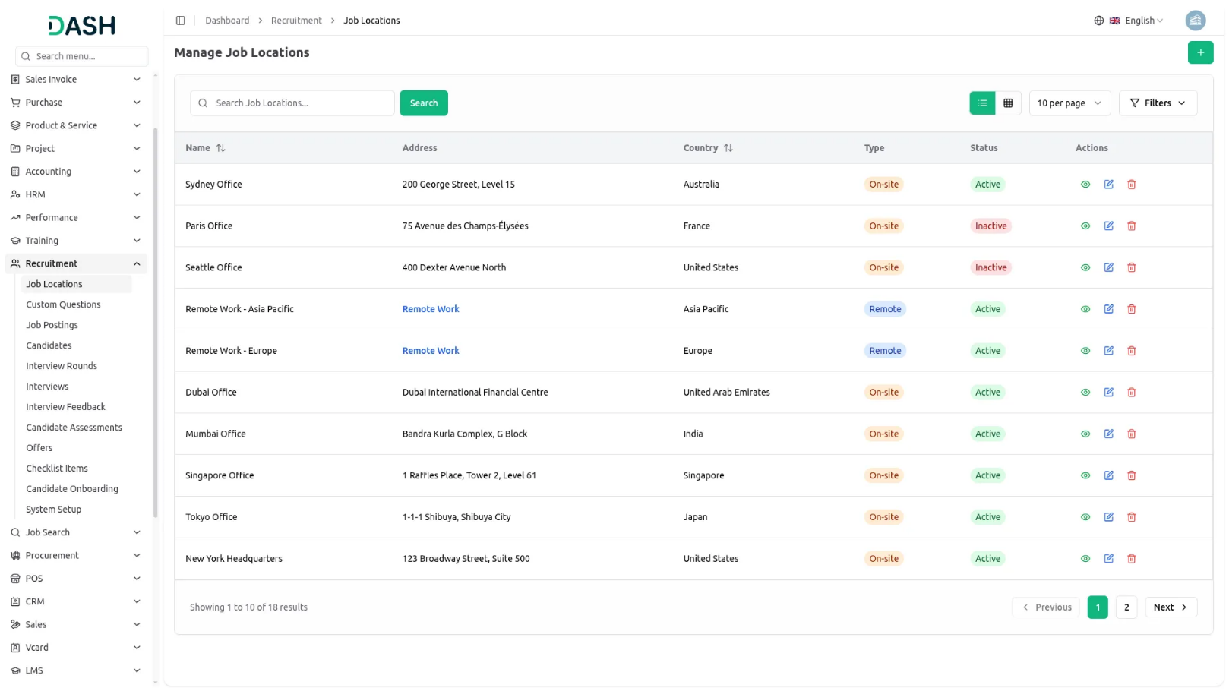
Manage Custom Questions
- To create a new Custom Question, click the “Create” button. Enter your Question text and select the Question Type from the dropdown, including Text, Textarea, Select, Radio, Checkbox, Date, or Number. If you choose Select, Radio, or Checkbox as the question type, an Options field will appear where you can enter the available choices.
- Check the Is Required checkbox if this question must be answered by candidates. Check the Is Active checkbox to make the question available for use. Enter a Sort Order number to control where this question appears in the application form. Click “Submit” to create the question.
- The list page shows all custom questions with columns for Question, Type, Is Required, Is Active, and Sort Order. Use the Search button to find specific questions or click Grid View to change the display.
- With the help of the Actions column, you can use a View to see the complete question details. You can edit the question to modify any settings or delete it if no longer needed.
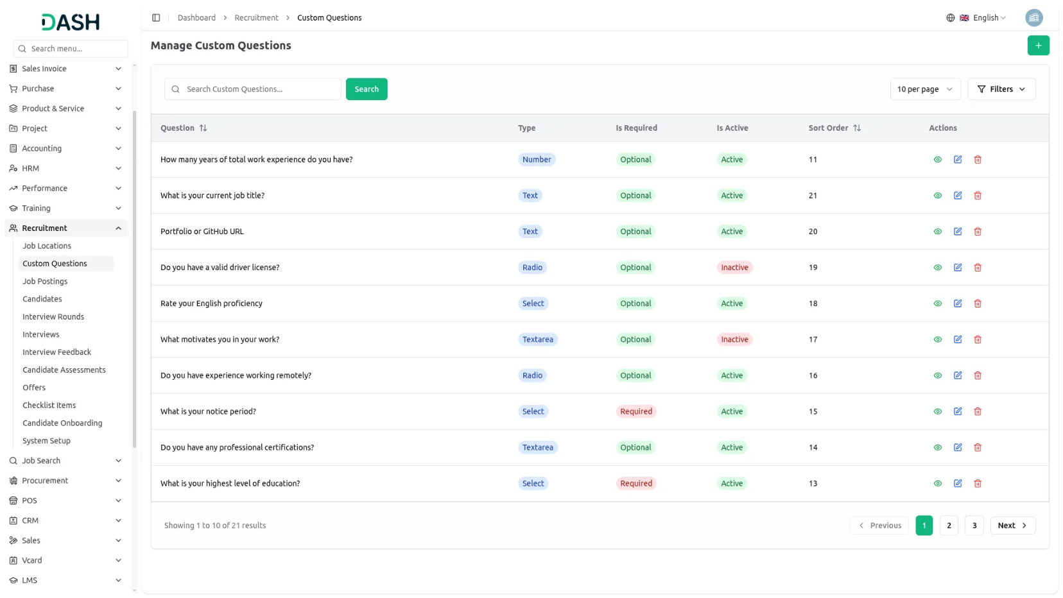
- On the website, all the custom questions that you create here are displayed on the Application page of the website, and you can also select which specific questions to include when creating a job posting, allowing you to customise and manage the application process according to your hiring needs.

Manage Job Posting
- To create a new Job Posting, click the “Create” button. In the Job Details section, enter the Job Title, then select the Job Type from the dropdown (which comes from Job Types in System Setup) and choose the Job Location from the dropdown (which comes from Job Locations you have created).
- Select the Branch from the dropdown (which comes from the HRM add-on Branch section). When you select the job application dropdown, if you choose “Use Existing System”, the “Career Portal URL” field will appear where you can enter the system’s URL. Alternatively, if you opt for “Custom Application URL,” the “Application URL” field will display a custom link automatically.
- Enter the number of positions, choose priority from the dropdown (low, medium, high), enter the Min Experience and Max Experience in years, then add the Min Salary and Max Salary.
- Set the Application Deadline date, and check the a need to ask? Section (Gender, Date Of Birth, Country), or check the Need to show Option? The section (Profile Image, Resume, Cover Letter) selected check box automatically shows in create in the candidate form.
- Enter the Required Skills for the position, then fill in the Description, Requirements, and Benefits fields with detailed information. Add Terms & Conditions text, and check the Show Terms & Conditions on Application Form checkbox if you want candidates to see and accept these terms when applying.
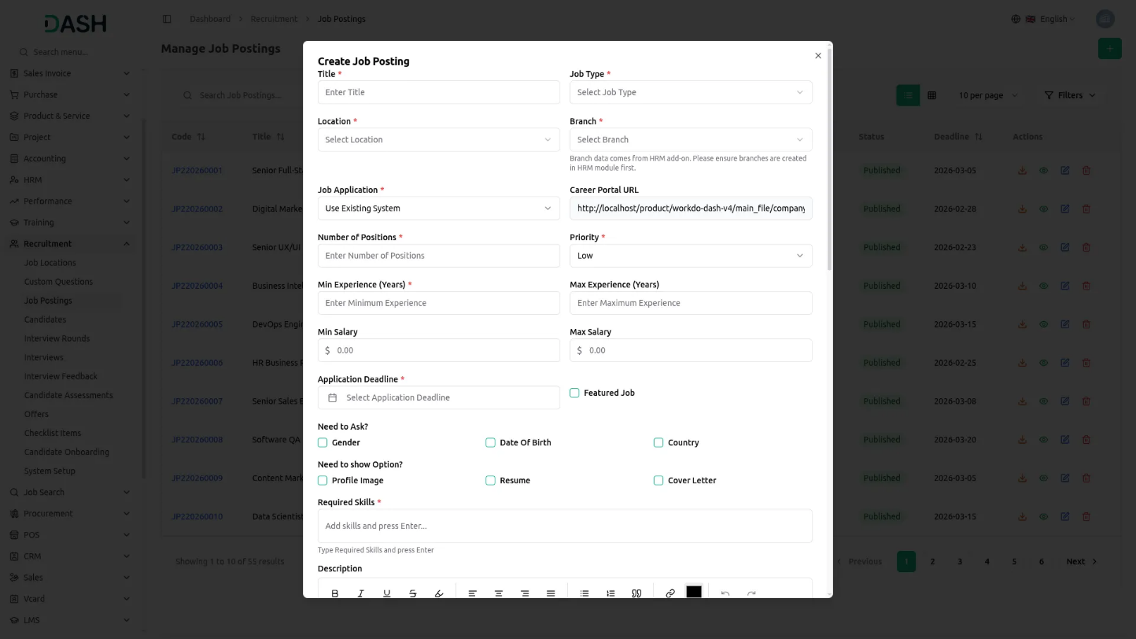
- Finally, select Custom Questions by checking the boxes next to the questions you want to include (these come from the Custom Questions section). Once complete, click “Save” to create the job posting.

- The list page shows Search, Create, and Grid View buttons. The table displays columns for Code, Job Title, Job Type, Location, Branch, Salary Range, Status, and Deadline.
- In the Actions column, you can toggle the Publish Status button to make the job visible or hidden on your career portal, click View to see complete Job Posting Details, Edit to modify the posting, or Delete to remove it.
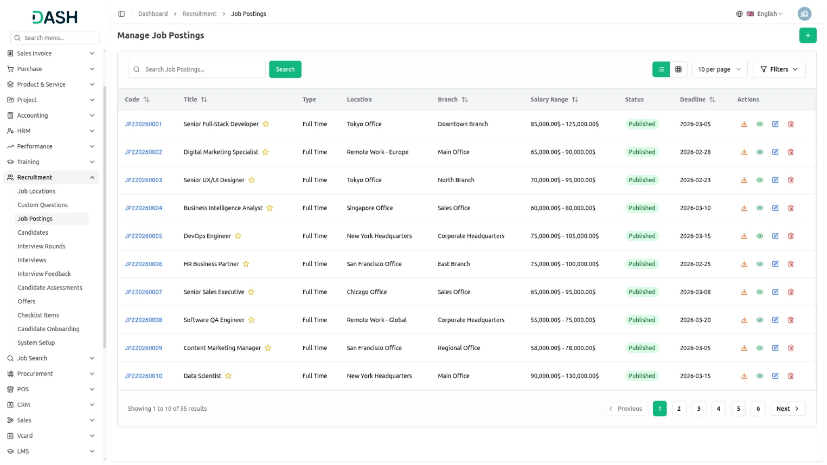
- On the website, the job postings you create here are displayed on your website’s career page, and the descriptions, requirements, and benefits you enter will appear on the website’s Job Application detail page.
- When candidates visit your career portal website, they can browse all published job listings in a scrollable list format, with each job displaying its title, company location, job type, number of available positions, and a “View details” button.
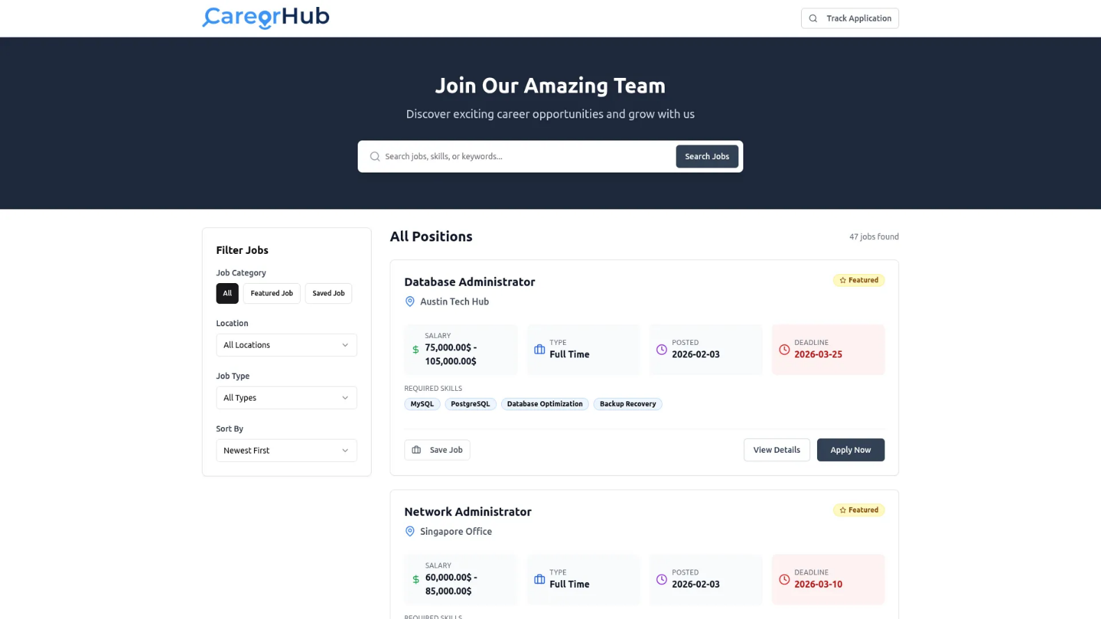
- Candidates can click the “View details” button on any job listing to access the detailed job page, which displays the complete job information, including salary range, job type, number of positions available, and application deadline in organized information boxes at the top.
- The job detail page shows the Required Skills tags, followed by sections for Job Description, Job Requirements, and Benefits that contain all the information you entered when creating the posting.
- On the right side of the job detail page, candidates will see a “Ready to Apply?” panel with the “Apply for This Position” button to start their application and a “Save for Later” button to bookmark the job for future reference.
- The right panel also displays important dates, including when the job was posted, the application deadline, and the expected start date, along with an “About the Company” section showing your company’s mission, size, and industry (which comes from the About Company Section in System Setup).
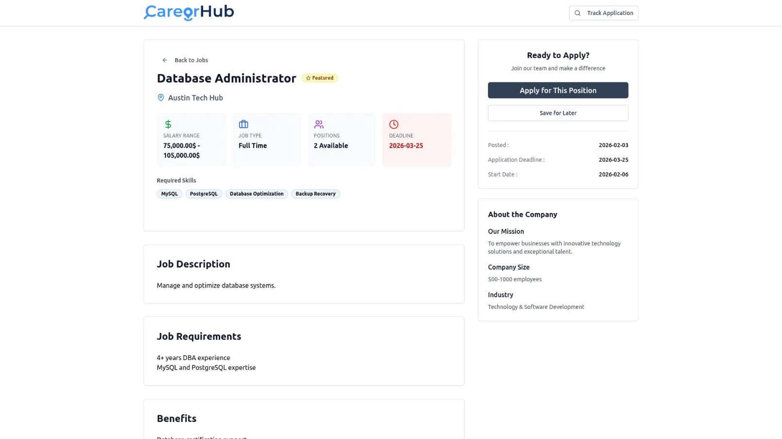
- When candidates click “Apply for This Position”, they are directed to the application form page where they need to fill in their Personal Information, including Full Name, Email Address, Phone Number, Gender, Country, State, City, and, optionally, upload a Profile Photo.
- In the Professional Information section of the application form, candidates enter their Current Company, Current Position, Experience Years, Current Salary, Expected Salary, Notice Period, Skills, Education, Portfolio URL, and LinkedIn URL.
- The Application Questions section displays the custom questions you selected when creating the job posting, including work authorisation status, expected salary range selection, and technology experience checkboxes for various programming languages and tools.
- If you enabled the Show Terms & Conditions checkbox when creating the job posting, candidates must check the “I have read and agree to the terms and conditions” box before they can submit their application.
- After candidates complete all required fields and click the “Submit Application” button, their application is submitted to your system and they can track their application status using the “Track Application” feature in the career portal header.
- All submitted applications from the career portal are automatically captured in your Candidate Management section, where you can review, process, and manage them through your recruitment workflow.
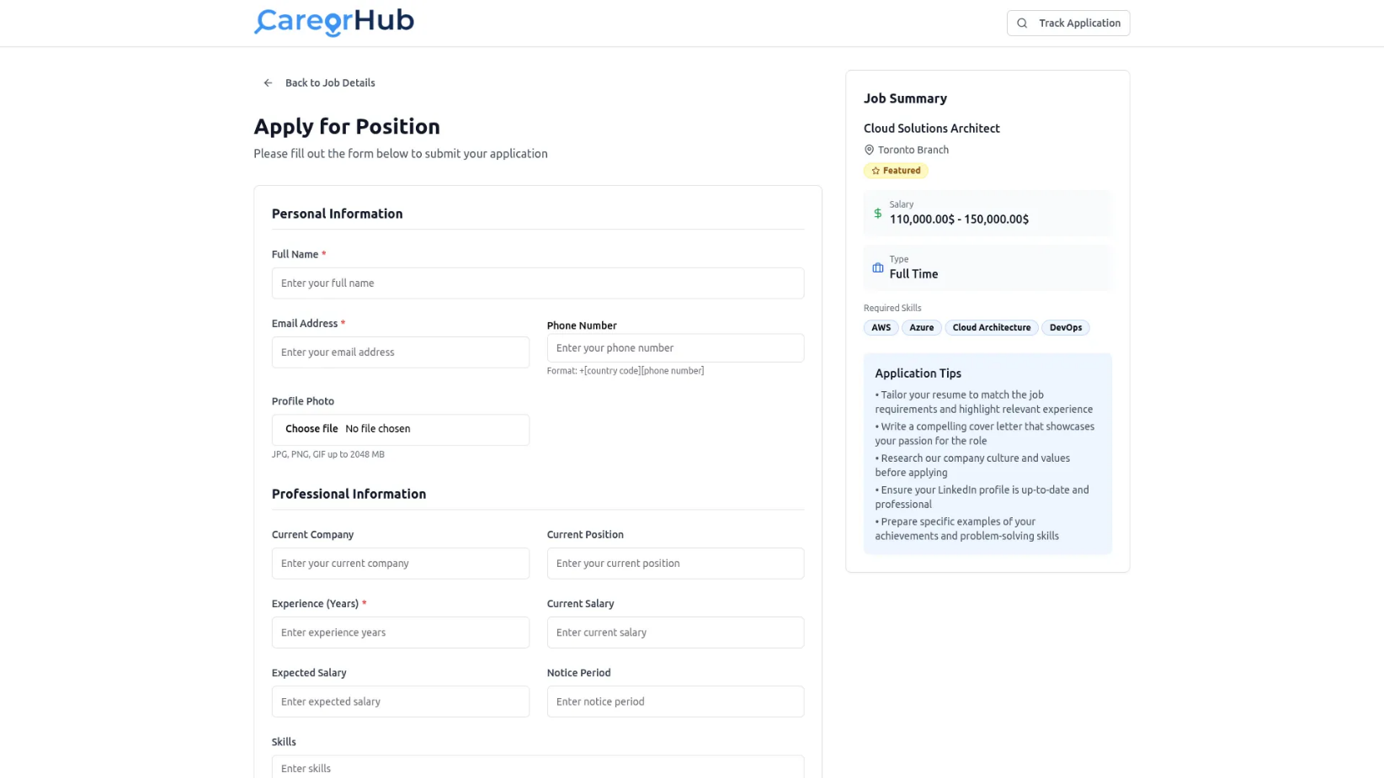

Manage Candidate
- To add a new Candidate, click the “Create” button. Select the job from the dropdown(which is generated from the job posting section), and choose the Candidate Source from the dropdown (which comes from Candidate Sources in System Setup).
- In the Personal Information section, enter the First Name, Last Name, Email, Phone, and current company or current position, and add the experience year. Fill in the Current Salary, Expected Salary, and Notice Period in days.
- The custom questions will appear as checkboxes on the job posting creation page, allowing the recruiter to select and configure which questions should be included in the application form at the time of job posting creation. These questions will then be shown to candidates when they apply for the job.
- Fill in all required answers and click “Submit” to create the candidate record.
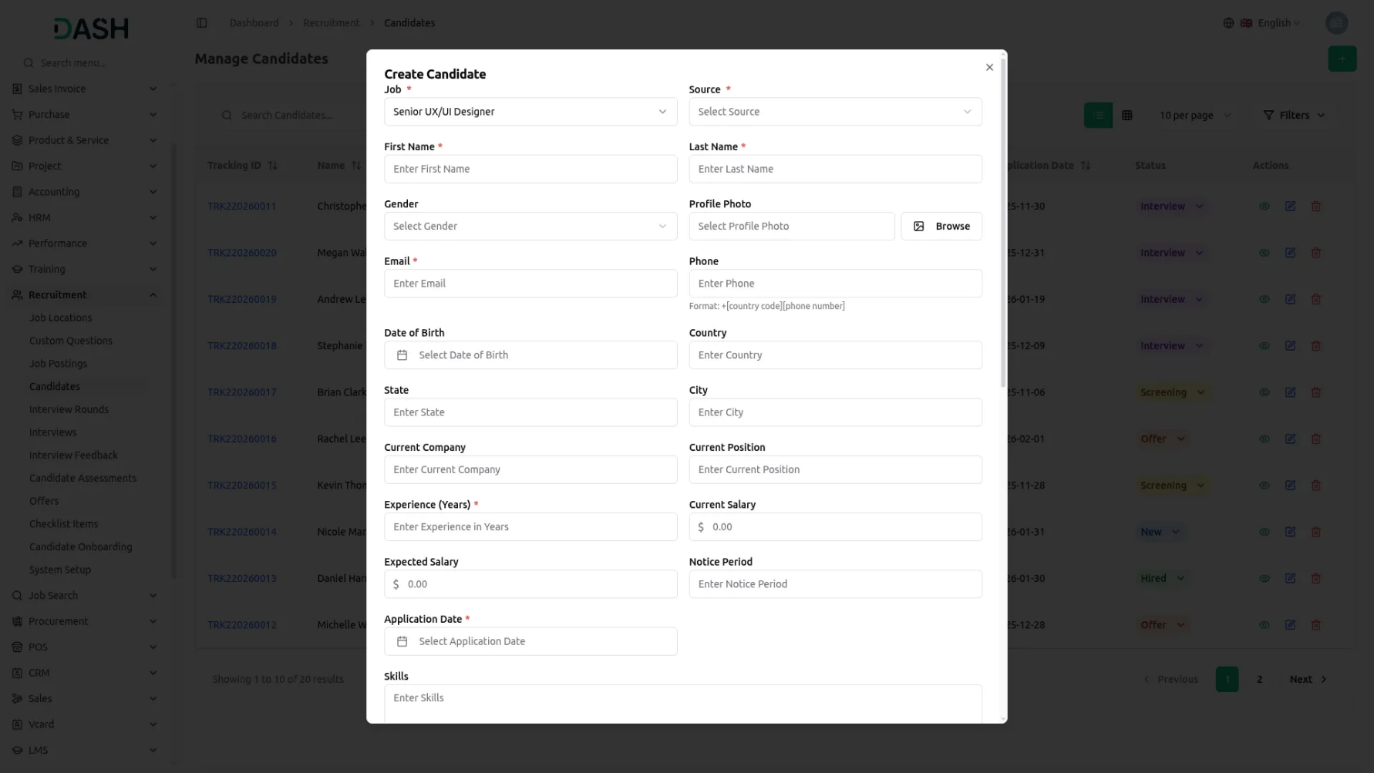
- The list page shows all candidates with columns for Tracking ID, Name, Email, Job, Source, Status, and Application Date. Use the Search button to find specific candidates or switch to Grid View.
- Available Actions you can use: click View to see the Candidate Profile, Professional Information, Job & Salary Information, and Application Questions with all submitted answers. You can edit the candidate information to update any details or delete the record if needed.
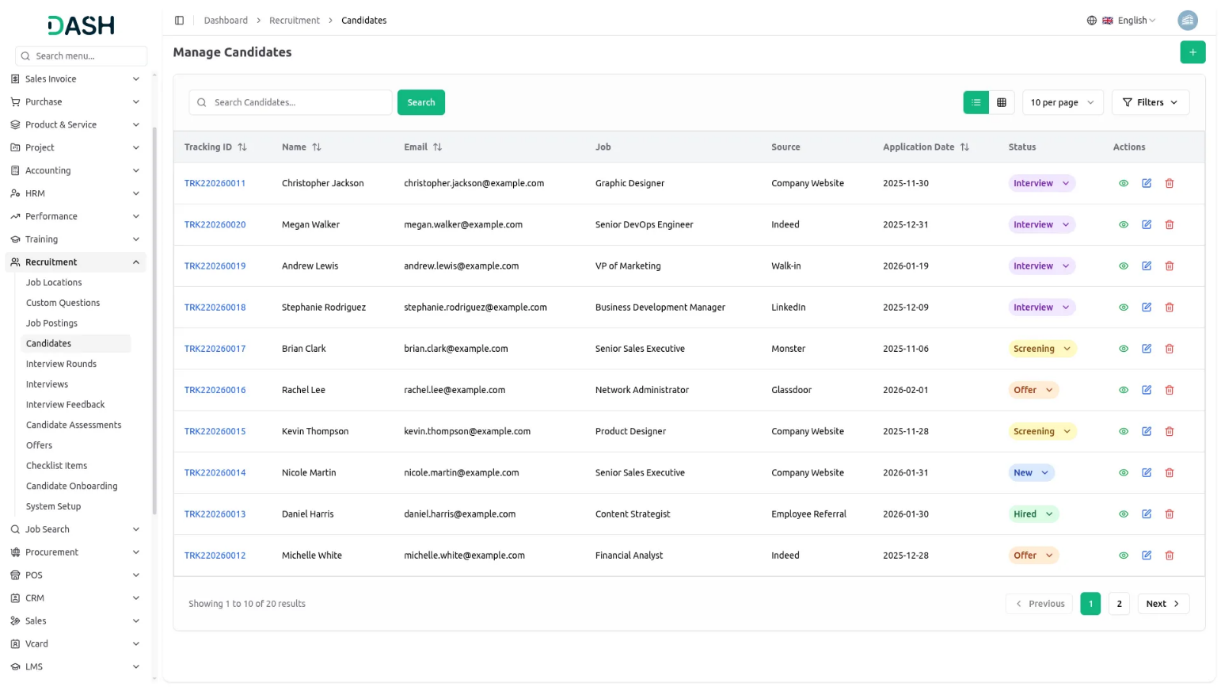
- On the website, when a candidate applies for a job, they will be able to add the same job posting data during the application process. The data from the job posting, including any custom questions added, will automatically populate the application form, allowing the candidate to provide the required details and answer the custom questions before submitting their application.
Manage Interview Rounds
- To create a new Interview Round, click the “Create” button. Select the Job Posting from the dropdown (which comes from the Manage Job Posting section). Enter the Round Name, such as Technical Round, HR Round, or Final Round.
- Enter the Sequence Number to define the order in which this round occurs in the interview process. Add a Description explaining what this round covers and select the Status as Active or Inactive. Click “Submit” to create the interview round.
- The list page displays all interview rounds with columns for Round Name, Job, Sequence, and Status. Use the Search button to find specific rounds or switch to Grid View.
- With the Actions column, you can use a View to see the complete interview round details. You can edit the round to modify any information or delete it if no longer needed.
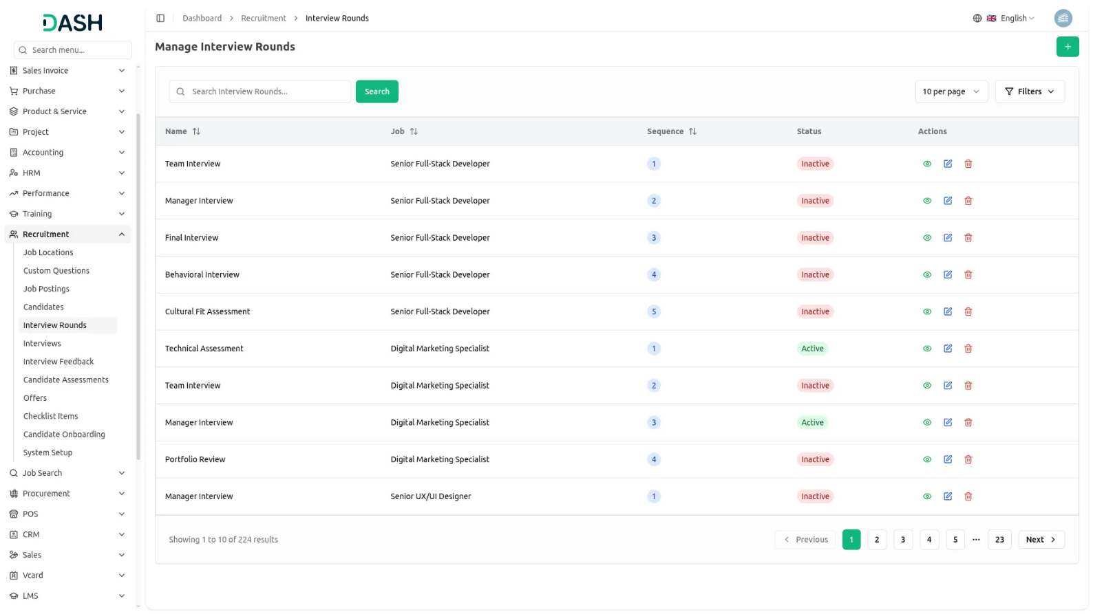
Manage Interview
- To schedule a new Interview, click the “Create” button. Select the Candidate from the dropdown (which comes from the Manage Candidate section). Choose the Interview Round from the dropdown (which comes from the Manage Interview Rounds section).
- Select the Interview Type from the dropdown (which comes from Interview Types in System Setup). Enter the Scheduled Date and Scheduled Time for the interview. Fill in the Duration in minutes and provide the Location or Meeting Link details.
- Select the Interviewers from the dropdown (which comes from HRM Employees). You can select multiple employees who will conduct the interview. Click “Submit” to schedule the interview.
- The list page shows all interviews with columns for Candidate Name, Interview Round, Interview Type, Date & Time, Locations, Status, and Feedback. Use the Search button to find specific interviews or switch to Grid View.
- Available actions you can use: View to see complete Interview Details, including candidate information, round details, interviewer names, and schedule. You can edit the interview to reschedule or update any information, or delete it if cancelled.
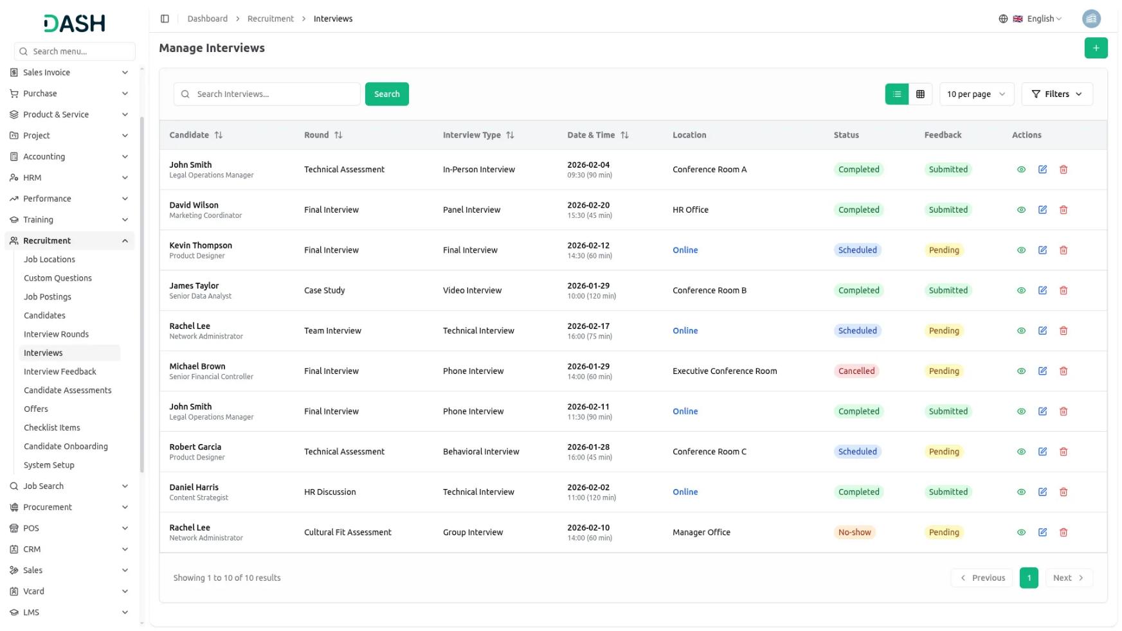
- When updating an interview status to “Completed”, the system automatically advances the candidate status from “Interview” to “Offer” stage. This ensures seamless progression through the recruitment pipeline without manual intervention.

- On the website, candidates can track the progress of their application through a timeline that highlights key stages: Application Submitted, Screening, Interview, and Final Decision. Interview details, such as the date, time, and virtual meeting link, are automatically updated based on the information entered, ensuring candidates have the most current details throughout the hiring process.
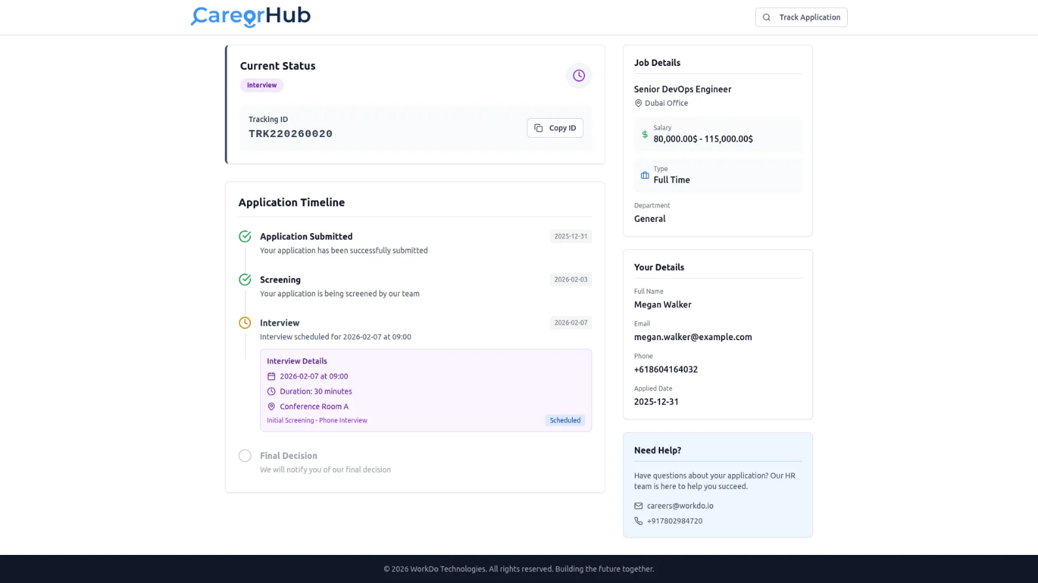

Manage Interview Feedback
- To submit Interview Feedback, click the “Create” button. Select the Interview from the dropdown, which shows only completed interviews from the Manage Interview section. Choose the Interviewer from the dropdown (which comes from HRM Employees) and shows only the employee who conducted that specific interview.
- Rate the candidate’s Technical Skills, Communication Skills, Cultural Fit, and Overall Rating on a scale of 1 to 5. Select your Recommendation from the dropdown with options including Strong Hire, Hire, Maybe, No Hire, or Strong No Hire.
- Write the candidate’s Strengths, Weaknesses, and add any additional Comments about the interview. Click “Submit” to save the feedback.
- The list page displays all feedback records with columns for Candidate Name, Interviewer, Submitted Date, Overall Rating, and Recommendation. Use the Search button to find specific feedback or switch to Grid View.
- In the Actions column, click View to see Complete Feedback with all ratings and comments, Interview Details, and Candidate Comparison to see how this candidate compares with others. You can edit the feedback to update your assessment or delete it if needed.
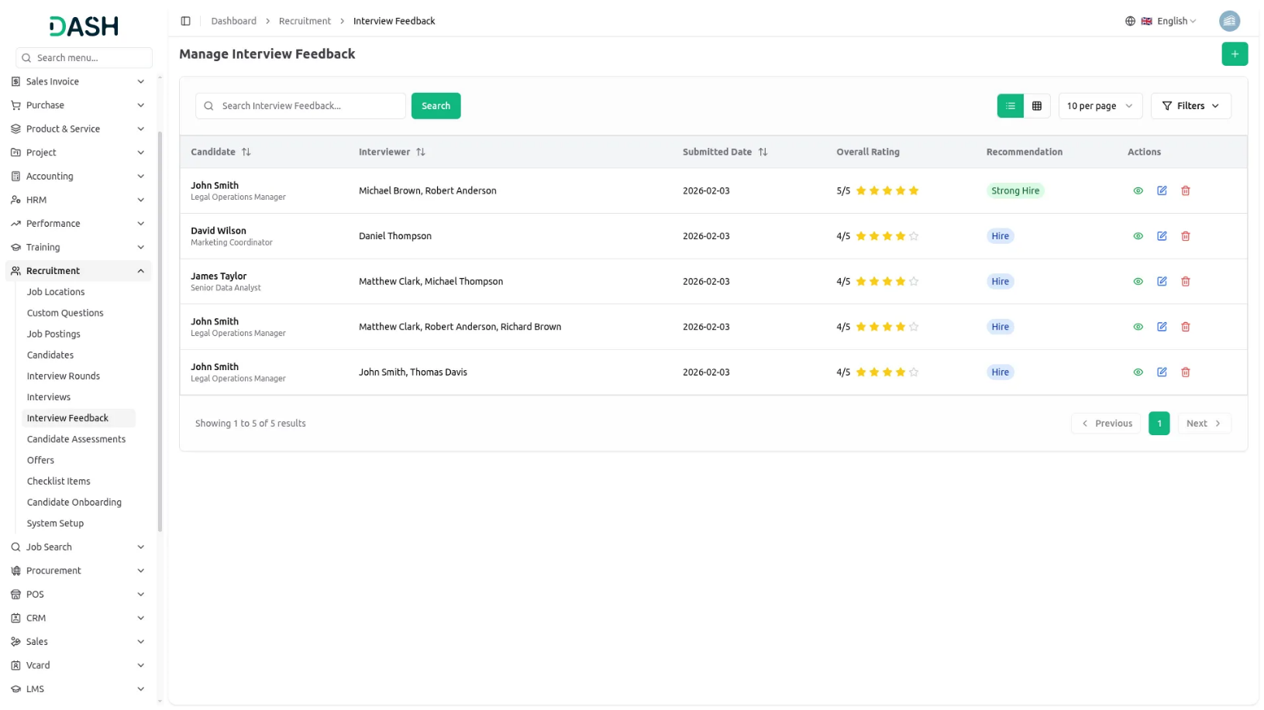

Manage Candidate Assessment
- To create a new Candidate Assessment, click the “Create” button. Select the Candidate from the dropdown, which shows only candidates with Strong Hire or Hire recommendations from interview feedback. Enter the Assessment Name, describing what is being tested.
- Fill in the Score achieved by the candidate and the maximum score possible. Select the Status as Pending, Pass, or Fail. Choose who conducted the assessment from the dropdown (which comes from HRM Employees).
- Enter the Assessment Date and add any Comments about the assessment results. Click “Submit” to create the assessment record.
- The list page shows all assessments with columns for Candidate Name, Assessment, Score, Conducted By, Status, and Assessment Date. Use the Search button to find specific assessments or switch to Grid View.
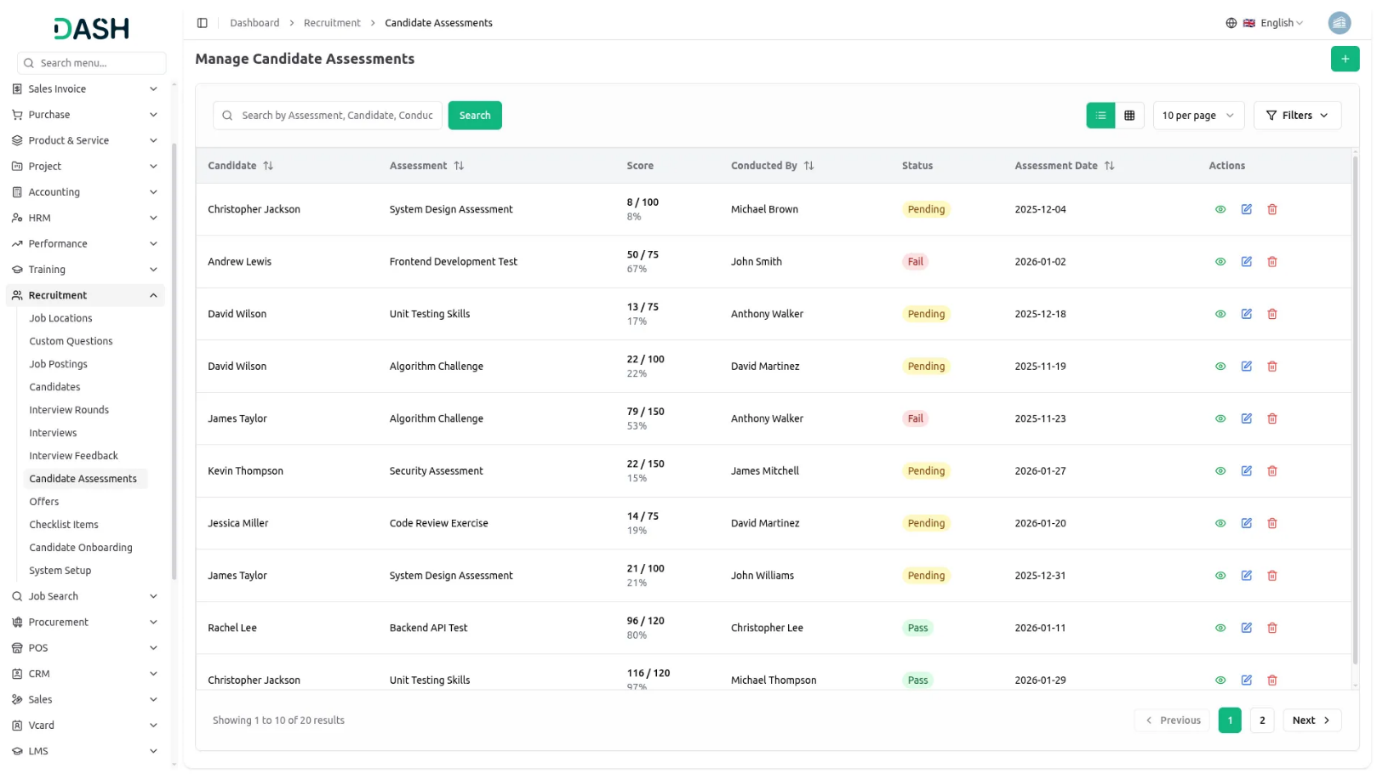
- With the help of the Actions column, you can use View to see complete Assessment Details, including all scores and comments. You can edit the assessment to update the results or delete it if needed.

Manage Offer
- To create a new Offer, click the “Create” button. Select the Candidate from the dropdown that comes from the Manage Candidate section. Enter the Position Title and choose the Department from the dropdown (which comes from the HRM Department).
- Fill in the Salary amount, Bonus, and Equity details. Enter the Start Date and Offer Expiry Date to specify when the offer expires. Add information about the Benefits included in the offer package. Click “Submit” to create the offer.
- The list page displays all offers with columns for Candidate Name, Position, Salary, Start Date, Expiration Date, Status, Offer Date, and Approval Status. Use the Search button to find specific offers or switch to Grid View.
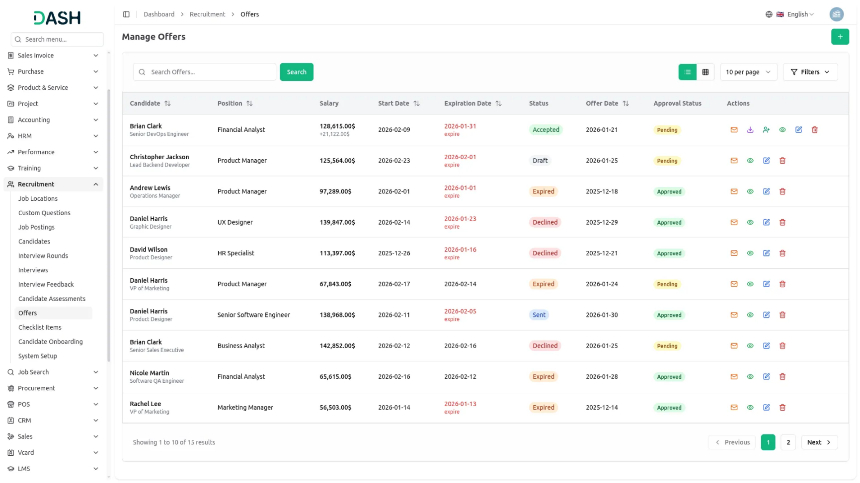
- In the Actions column, you will find several options. Click Send Offer Letter to email the offer to the candidate or Download Offer Letter to save a copy. If the candidate accepts the offer, use the Convert to Employee button to move them into your HRM system. This automatically updates the candidate status from “Offer” to “Hired” upon successful conversion. Click View to see complete Offer Details and access the Offer Approved or Reject option to change the approval status. You can also edit the offer to update any terms or delete it if withdrawn.

Manage Checklist Items
- To create a new Checklist Item, click the “Create” button. Select the Checklist from the dropdown (which comes from Onboarding Checklists in System Setup). Enter the Task Name and provide a Description of what needs to be done.
- Choose the Category from the dropdown with options including Documentation, IT Setup, Training, HR, Facilities, or Other. Select the Assigned To Role to specify which team should handle this task. Enter the Due Day number, indicating how many days after onboarding starts this task should be completed.
- Toggle the Required Task switch to mark if this task is mandatory. Select the Status as Active or Inactive. Click “Submit” to create the checklist item.
- The list page shows all items with columns for Checklist Name, Task, Category, Assigned To Role, Due Day, and Status. Use the Search button to find specific items or switch to Grid View.
- In the Available Actions column, you can use View to see complete Checklist Item details. You can edit the item to update any information or delete it if no longer needed.
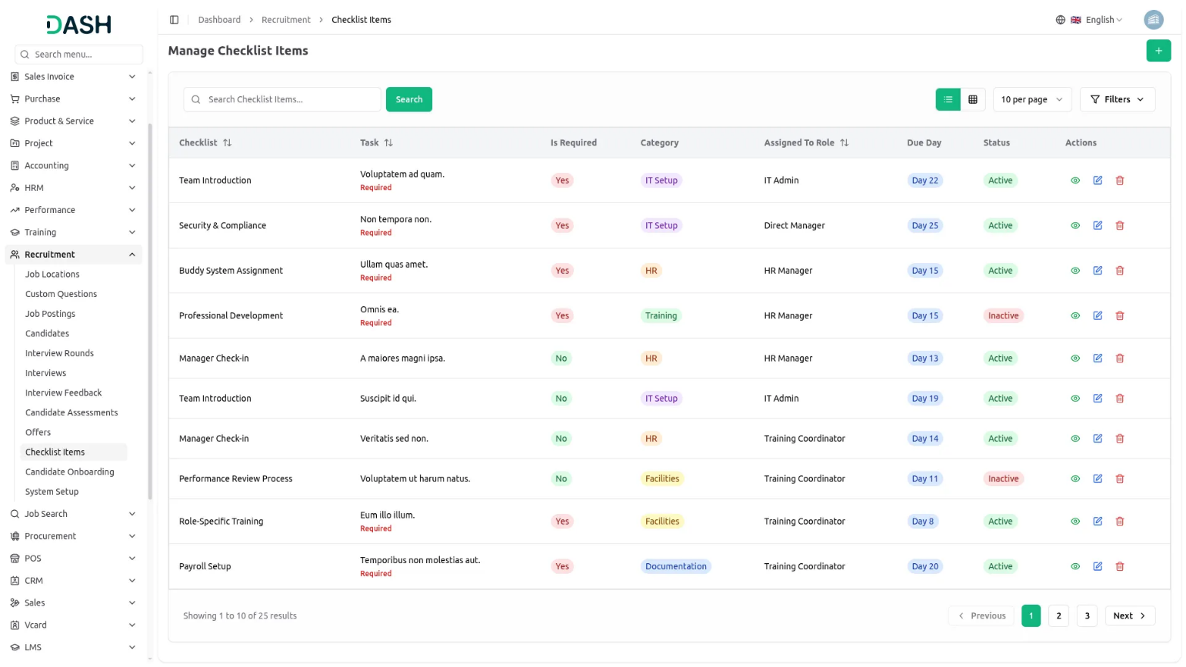
Manage Candidate Onboarding
- To start Candidate Onboarding, click the “Create” button. Select the Candidate from the dropdown, which shows only hired candidates from the Manage Candidate section. Choose the Onboarding Checklist from the drop-down (which comes from Onboarding Checklists in System Setup).
- Enter the Start Date when the candidate will begin onboarding. Select a Buddy Employee from the dropdown (which comes from HRM Employees), who will guide the new hire through the process. Click “Submit” to create the onboarding record.
- The list page displays all onboarding records with columns for Candidate Name, Checklist Name, Start Date, Buddy Name, Status, and Created Date. Use the Search button to find specific records or switch to Grid View.
- In the Actions column, click View to see complete Onboarding Details, including all tasks, progress, and timeline. You can edit the onboarding to change the checklist or buddy assignment, or delete it if needed.
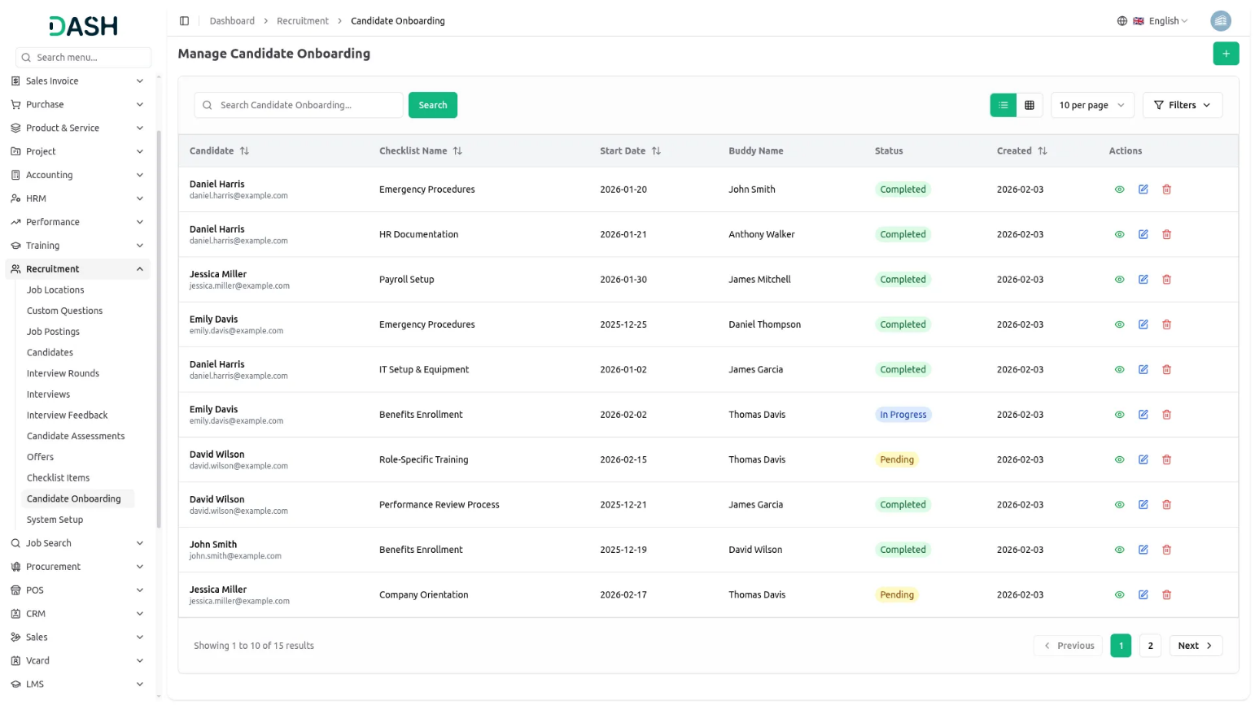
System Setup
Manage Job Type
- In the System Setup section, you will find the Manage Job Type section. To add a new job type, click the “Create” button. Enter the Name, such as Full-Time, Part-Time, Contract, or Internship. Add a Description explaining this employment type. Check the Is Active checkbox to make this type available. Click “Submit” to save.
- The list page displays all job types with columns for Name, Description, and Is Active status. In the Actions column, you can edit the type to update information or delete it if not needed.
- Once saved, these job types will appear in the Job Type dropdown when creating Job Postings, allowing you to specify the employment arrangement for each position.
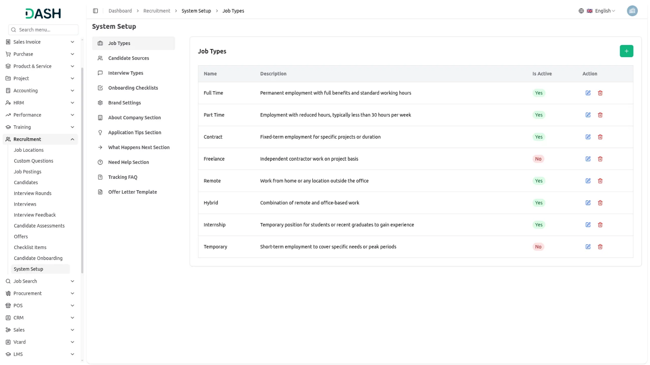

Manage Candidate Sources
- In the System Setup section, you will find the Manage Candidate Sources section. To add a new source, click the “Create” button. Enter the Name, such as LinkedIn, Indeed, Referral, or Career Fair. Add a Description explaining this source channel. Check the Is Active checkbox to make this source available for selection. Click “Submit” to save.
- The list page displays all candidate sources with columns for Name, Description, and Is Active status. In the Actions column, you can Edit the source to update details or Delete it if no longer needed.
- Once saved, these candidate sources will appear in the Candidate Source dropdown when adding candidates in the Manage Candidate section, helping you track where your applicants are coming from.
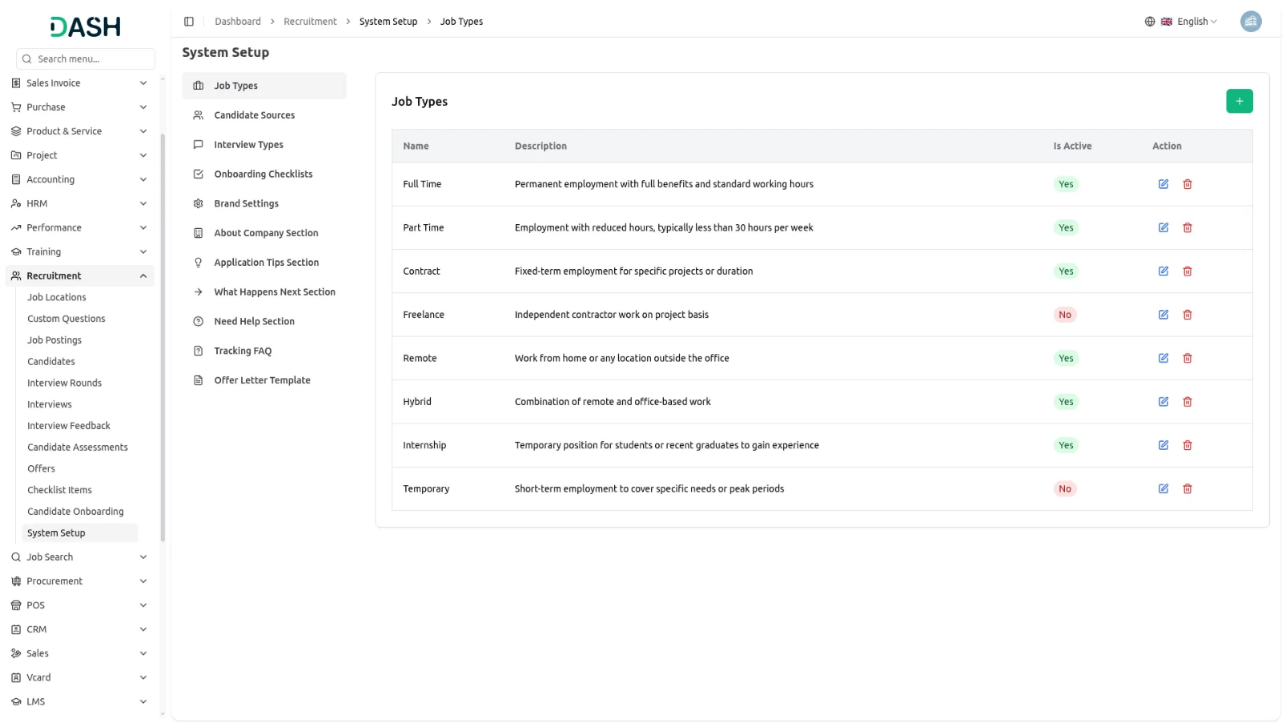

Manage Interview Types
- In the System Setup section, you will find the Manage Interview Types section. To add a new interview type, click the “Create” button. Enter the Name, such as Phone Screening, Video Interview, In-Person, or Panel Interview. Add a Description explaining this interview format. Check the Is Active checkbox to make this type available. Click “Submit” to save.
- The list page shows all interview types with columns for Name, Description, and Is Active status. In the Actions column, you can edit the type to update information or delete it if not needed.
- Once saved, these interview types will appear in the Interview Type dropdown when scheduling interviews in the Manage Interview section, allowing you to specify the format of each interview.
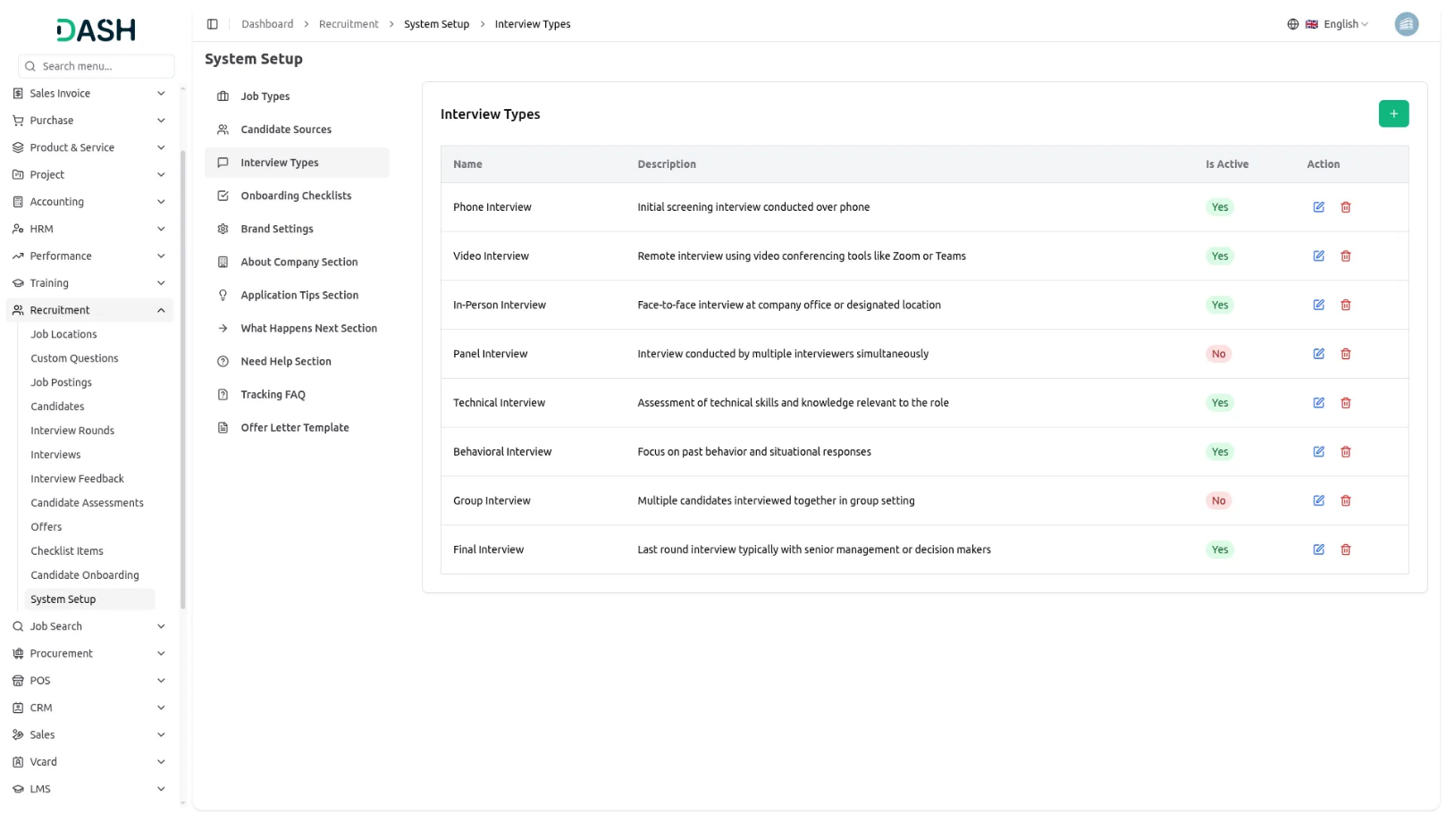

Manage Onboarding Checklists
- In the System Setup section, you will find the Manage Onboarding Checklists section. To create a new checklist, click the “Create” button. Enter the Name of the checklist, such as Standard Onboarding or IT Department Onboarding. Add a Description explaining when this checklist should be used.
- Check the Is Default checkbox if this should be the default checklist for new hires. Select the Status as Active or Inactive. Click “Submit” to save.
- The list page displays all checklists with columns for Name, Item count, Is Default status, and Status. In the Actions column, you can edit the checklist to update details or delete it if no longer needed.
- Once saved, these onboarding checklists will appear in the dropdown when creating Checklist Items and when starting Candidate Onboarding, providing structured task lists for new employee integration.
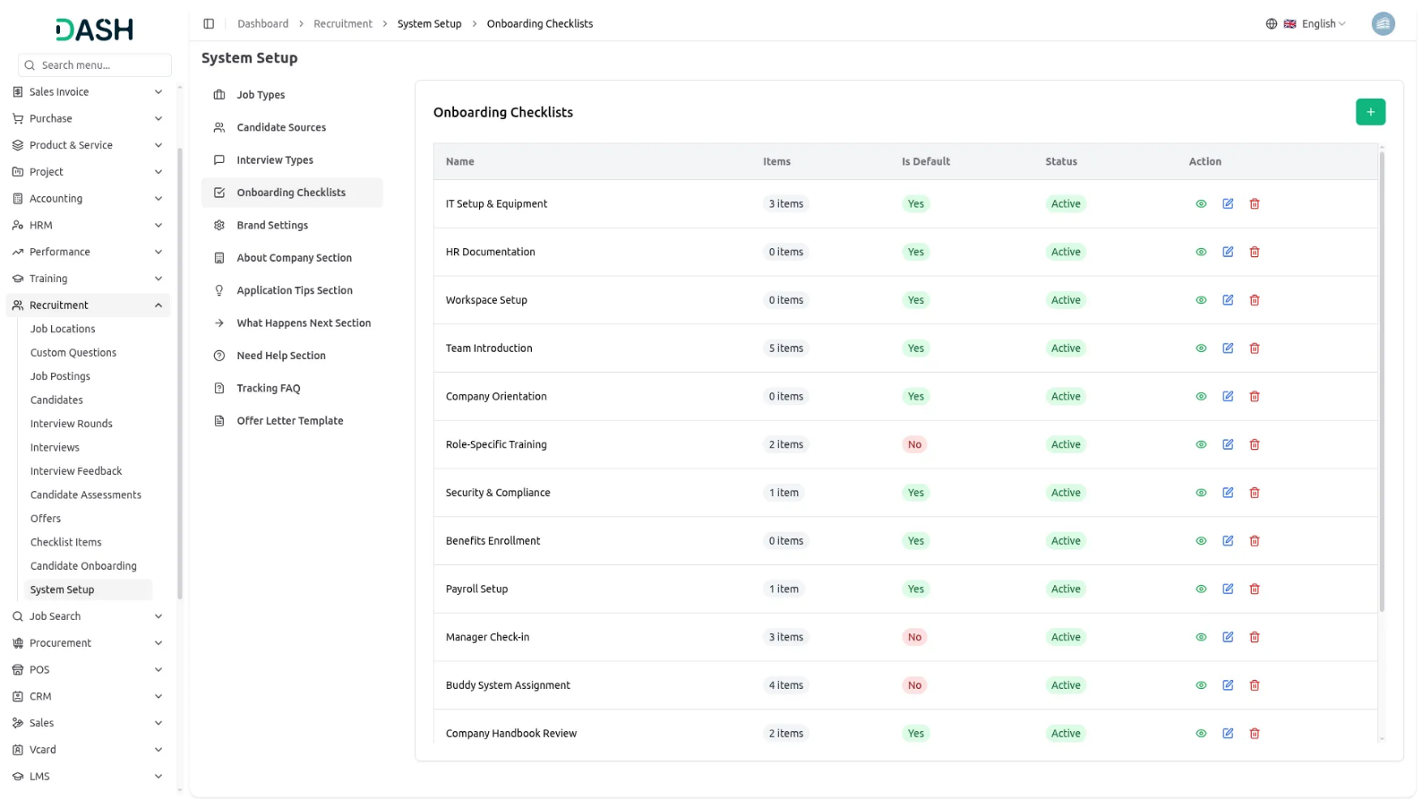
Brand Settings
- In the Brand Settings section, you will find fields for Company Logo, Favicon, Title Text, and Footer Text. Upload your Company Logo and Favicon images, then enter the Title Text and Footer Text.
- Once saved, your Company Logo and Favicon will appear throughout your career portal website. The Title Text will display in the header section, while the Footer Text will automatically appear at the bottom of every page on your frontend career portal, creating a consistent branded experience for candidates visiting your job site.
- In the Dashboard Welcome Card Settings section, you will find fields for Card Title, Card Description, Button Text, and Button Icon. Enter your Card Title and Card Description to introduce your recruitment system, then customise the Button Text and select an appropriate Button Icon from the dropdown menu. Click “Save Changes” to apply your settings.
- The welcome card will appear on your dashboard with your customised title and description. The button will display with your chosen text and icon, providing users with a clear call-to-action to access your career portal or other key features directly from the dashboard home screen.
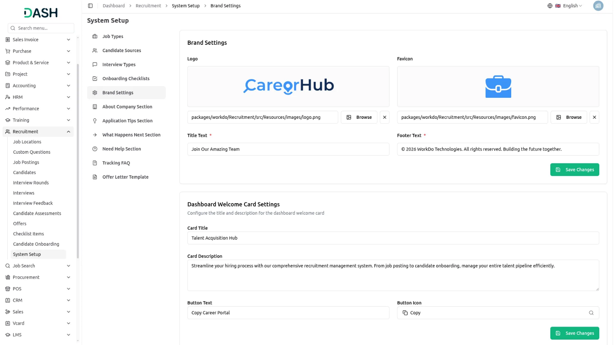
About Company
- In the About Company section, you will find fields for Our Mission, Company Size, and Industry. Enter your company’s mission statement explaining your purpose and values. Fill in the Company Size, indicating the number of employees, and specify your Industry sector. Click “Save” to apply the changes.
- Once saved, this information will automatically display in the About the Company section on the Job Details Page of your frontend career portal, giving candidates insight into your organisation when they view job openings.
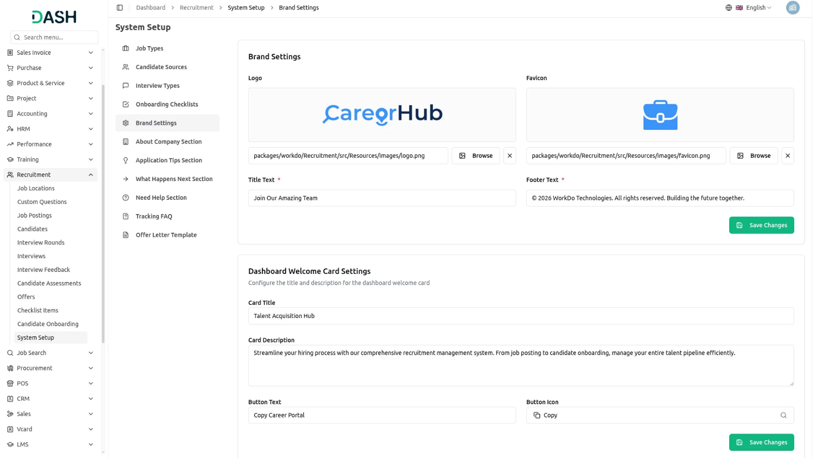

Application Tips
- In the Application Tips section, you will find a field for Tips Title where you can add multiple tips. Click the add button to create each new tip, entering helpful advice for candidates such as “Update your resume before applying” or “Include a personalised cover letter.” You can add as many tips as needed. Click “Save” to apply the changes.
- Once saved, these application tips will automatically display on the Job Application Page of your frontend career portal, guiding candidates on how to submit strong applications.
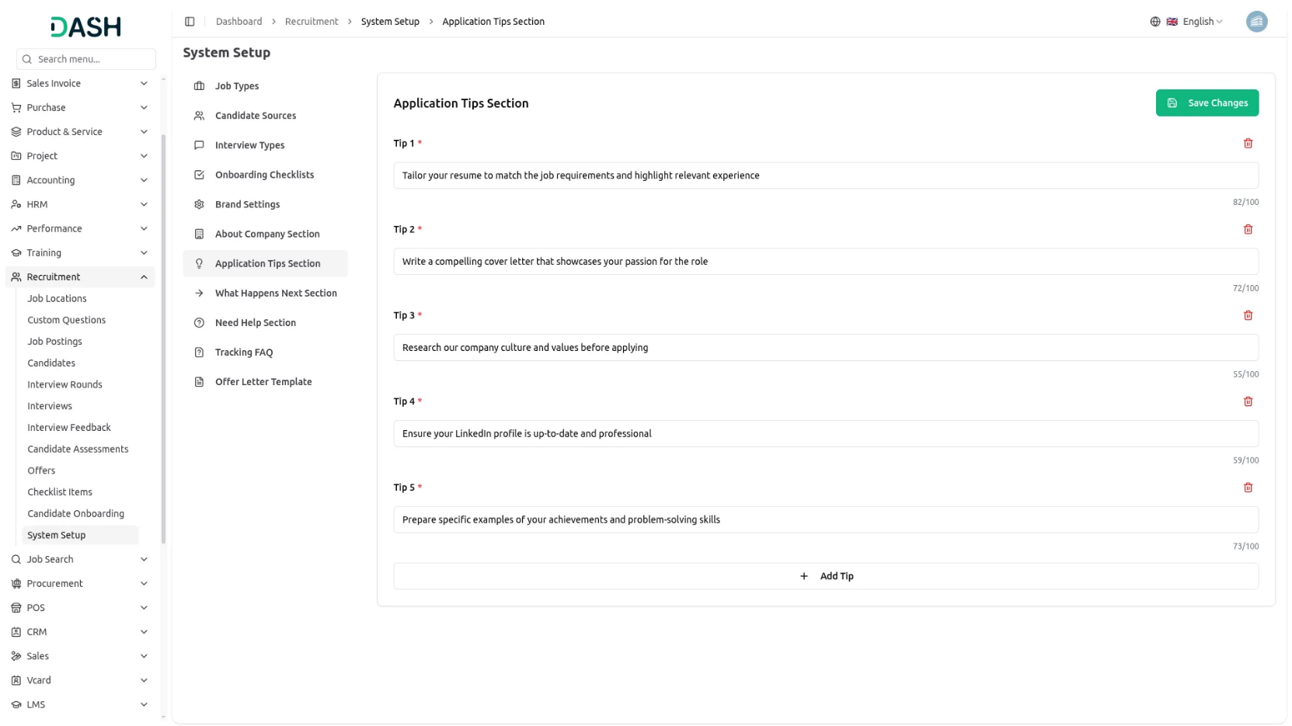

What Happens Next
- In the What Happens Next section, you will find fields for Title, Icon, and Description, and all these fields can be added multiple times. Click the add button to create each step in the process. Enter a Title such as “Application Review,” upload an Icon image, and write a Description explaining this stage. Repeat to add all steps in your hiring process. Click “Save” to apply the changes.
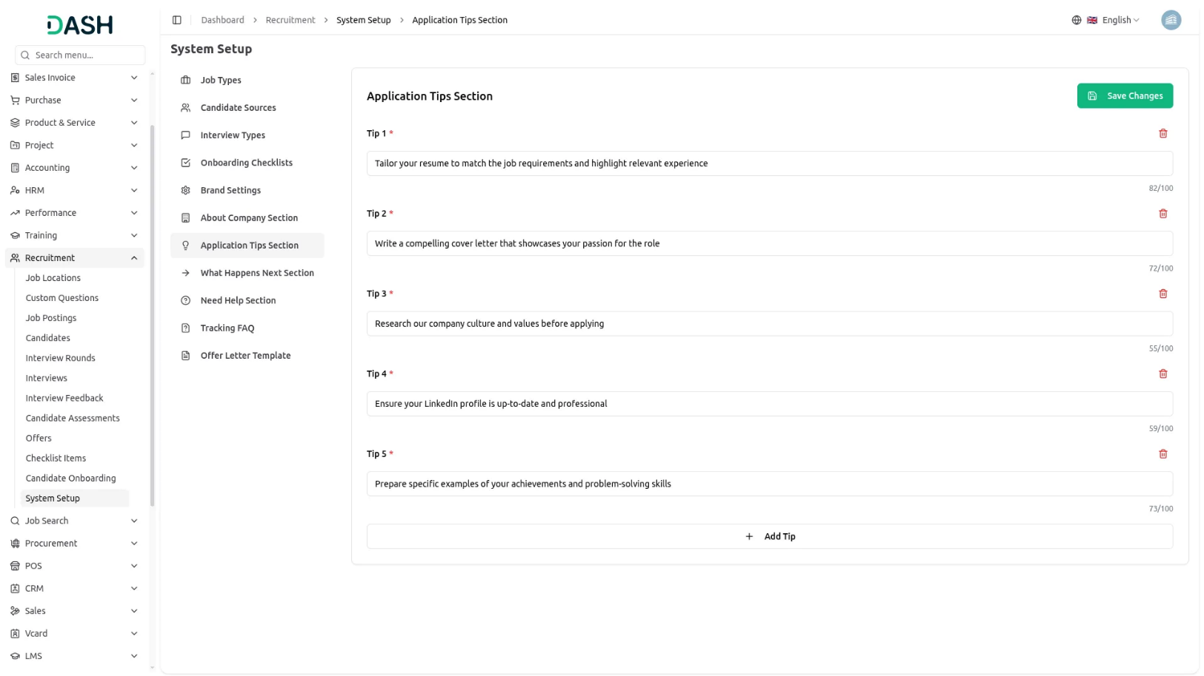
- Once saved, this information will automatically display on the Application Success Page of your frontend career portal after candidates submit their applications, helping them understand the timeline and next steps in your recruitment process.
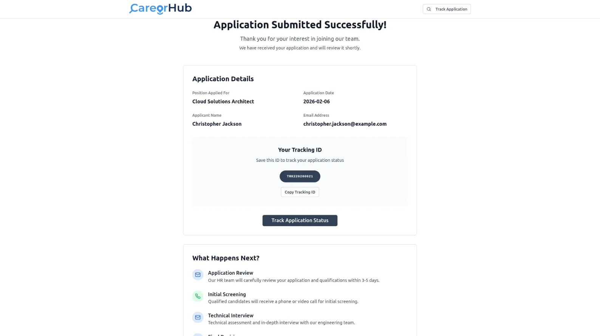

Need Help
- In the Need Help section, you will find fields for Description, Email, and Phone. Enter a Description with guidance on how candidates can get assistance. Fill in the Email address and Phone number where candidates can reach your recruitment team. Click “Save” to apply the changes.
- Once saved, this contact information will automatically display in the Need Help section on both the Application Success Page and Application Details Page of your frontend career portal, giving candidates a way to reach out if they have questions about their application.

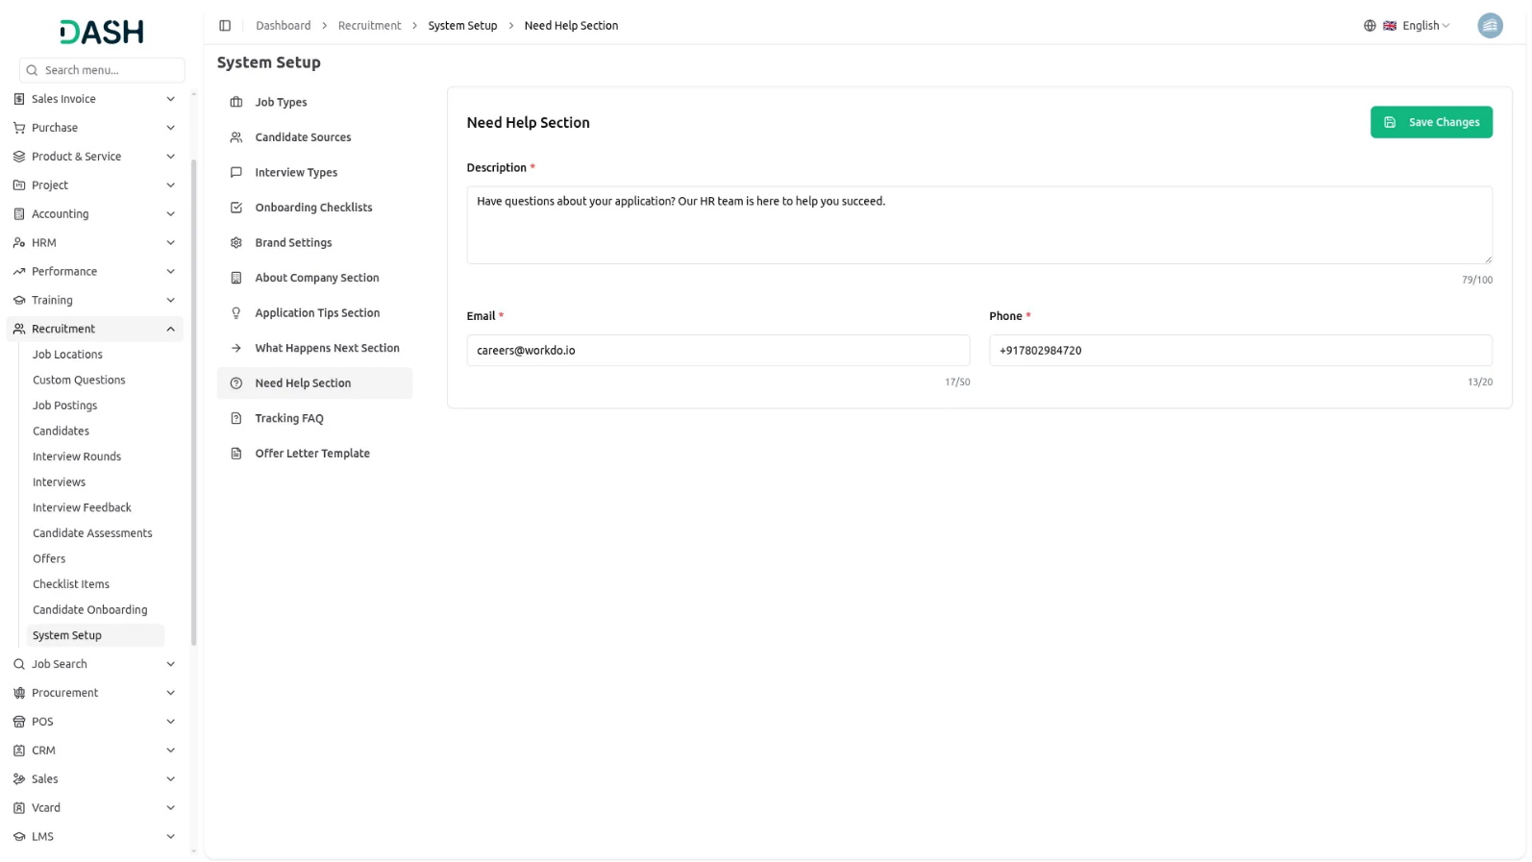

Tracking FAQ
- In the Tracking FAQ section, you will find fields for FAQ Question and FAQ Answer, and both fields can be added multiple times. Click the add button to create each FAQ entry. Enter a Question such as “How long does the review process take?” and provide the Answer. Repeat to add all frequently asked questions about application tracking. Click “Save” to apply the changes.
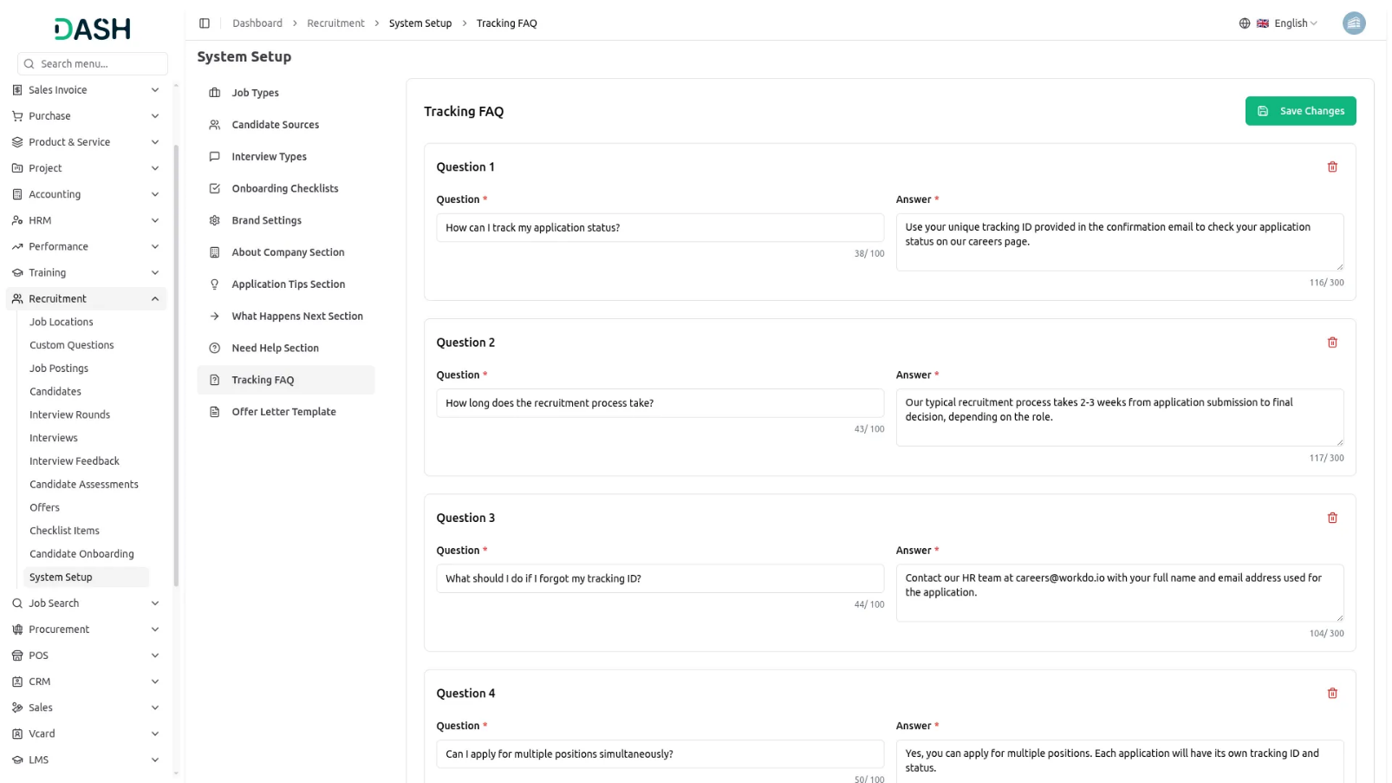
- Once saved, these FAQs will automatically display on the Application Tracking Page of your frontend career portal, helping candidates understand how to track and what to expect from their application status.
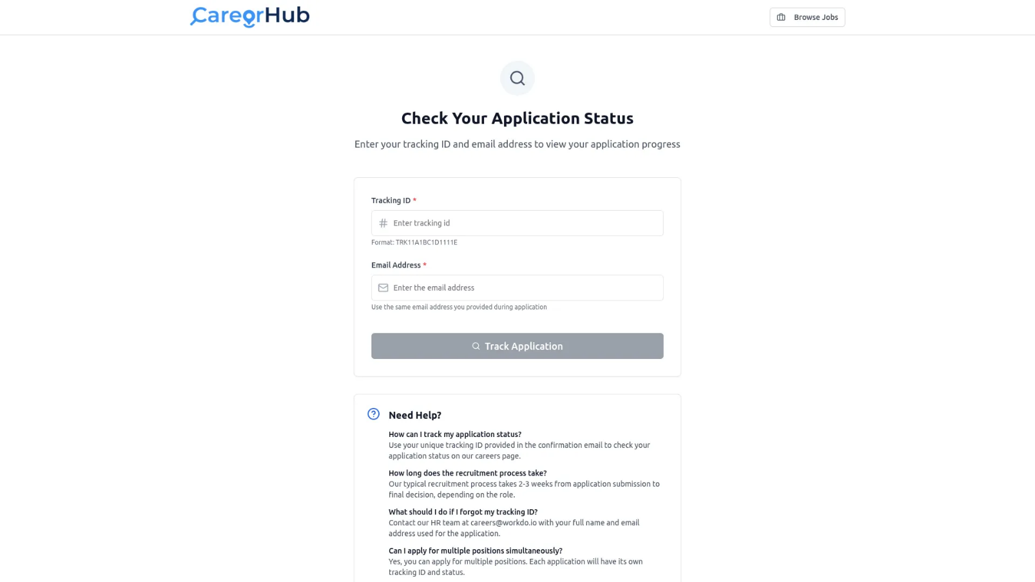
Offer Letter Template
- In the Offer Letter Template section, you will find a Template Content field with rich text formatting options. Write your offer letter content using the available formatting tools to style text, add paragraphs, and structure the document professionally.
- You will also see an Available Placeholders List showing variables you can insert into the template, such as candidate name, position, salary, and start date. Use these Template Variables by inserting them where needed in your content, and they will automatically populate with actual candidate data when generating offer letters. Click “Save” to apply the template.
- Once saved, this template will be used when you click Send Offer Letter or Download Offer Letter from the Manage Offer section, automatically generating personalised offer letters for candidates with their specific details filled in.
